Mid-term exam, 2009. nov. 23. Name: _________________________________ ID: _________
total 60 points : satisfactory 40%

Q1A. The FERISON syllogism is as follows: ∀x. C(x) → ¬ A(x)
∃x. C(x) ∧ B(x)
∃x. C(x) ∧ ¬ A(x)
Is it sound? Prove your answer with resolution! Take care of the Skolemization. (8 points)

Q2A. Is the next statement valid? Prove your answer with truth tables. (5 points)
(A XOR B) → (A ∨ B), where (A XOR B) = (A ∧¬B) ∨ (¬A ∧ B).

Q3A. What is the definition of the satisfiability of a logical expression? (5 points)

Q4A. In a simple world a robot can move blocks. Define am effect axiom in situation calculus. (8 points)

Q5A. Apply the algorithm A* from A to B and fill the cells according to the scheme on the right (h the value of heuristic, g denotes the minimal cost of the path, f is th total cost, and a is the altitude of the cell). The applied heuristics is the Manhattan distance (minimum number of steps using only the four neighbours). The real cost to a neighbouring cell is 1 + Δ, where Δ is the distance between the altitudes. Indicate the optimal path on the map! (12 points)

Q6A. What is a partially ordered plan? Give an example and describe the advantages and disadvantages. (12 points)

Q7A. What is an admissable heuristic function? Give an example.(5 points)

Q8A. What is a raional agent? (5 points)

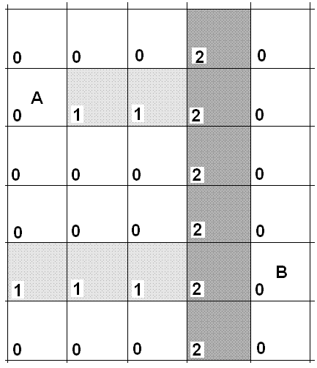
h g

a f

