Laboratory report
Subject of the exercise: | Basic Logic Circuits (Exercise 9.)
Date: | <year>. <month>. <day>
Location: | BME, lab.: Q. BP.109
Students name: | <name 1> ,<name 2>
Group, Desk No. | Group: <No.>, Desk: <No.>
Supervisor: | <name>
Measurement instruments
Digital multimeter (3½ digit) | METEX ME-22T
Power supply | Agilent E3630
Oscilloscope | Agilent 54622A
Function generator | Agilent 33220A
Test board | VIK-07
Laboratory exercises
The measurement tasks have to be performed by using 1pc of TTL and 1pc of CMOS type digital IC. It means that each measurement task has to be repeated to see the differences between the two type of ICs.
- Measurement of voltage transfer characteristic for several inverter IC type
  - Make the evaluation board ready for the measurement: connect a 5V power (to Vcc) and GND (to GND) to the Evaluation board using the Agilent E3630 power supply (Measure the supply voltage before connecting it !!!). See Figure 9–1.
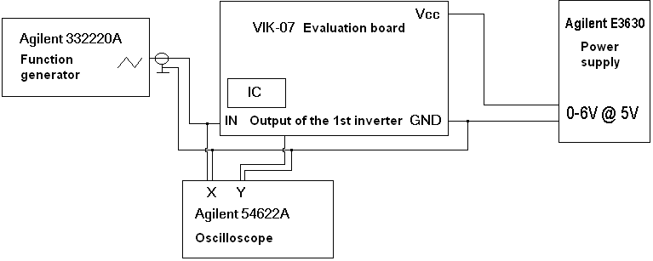
Figure 9–1.: Measurement setup of exercise 1.
  - Place a TTL inverter provided by the tutor into the inverter socket (bottom left of the panel). Use the Agilent 33220 function generator to generate a 0V to 5V triangle wave (2.5 V_{DC} 2.5 V amplitude) of 350 Hz frequency. Measure the generated signal before connecting it to the panel, because the improper selection of function generator’s load could cause problems! Ask for help if necessary! Connect the stimulus to the input of the inverter chain. Measure the voltage transfer characteristic of the first inverter using the XY mode of the oscilloscope. (Connect the stimulus to one channel of the oscilloscope and the output of the first inverter to the other channel of the oscilloscope.) Do not connect any load to the inverters’ output.
<your comments>
  - Connect a 10 gate load (“10 kapu terhelés”-as written on the panel) to the output of the first inverter. How the transfer characteristic changed?
<your comments>
  - Perform the following measurements for one TTL and one CMOS circuits! Measure the logic High and Low voltage levels, measure the High-to-Low, and Low-to-High switching points (switching level). Make conclusions on differences.
<your comments>
Measurement results:
Type of IC | Switching point | U_{L} | U_{H}
Type 1

Type 2

- Measure the power consumption of several inverters. Repeat this measurement for different input signal frequencies.
  - Use the Agilent 33220 function generator to create a 0V to 5V square wave at the frequency of 100 Hz. Measure the generated signal before connecting it! Connect a multimeter in current measurement mode between the power supply and the evaluation board. (See Figure 9–2.) Measure the static power consumption of the evaluation board (unlock and remove the inverter IC). Place back the inverter circuit, and perform the power consumption measurement. Repeat the measurement at 1kHz, 10KHz, 100Khz, 1MHz frequencies!
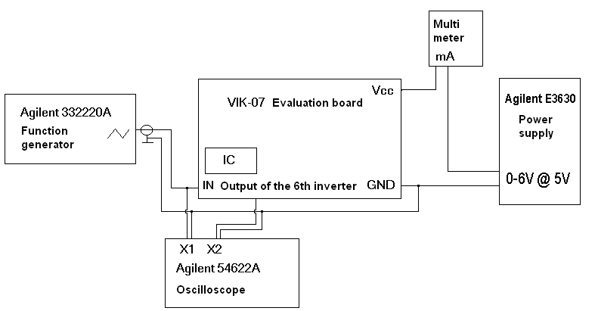
Figure 9–2.: Measurement setup of exercise 2.

TTL IC:
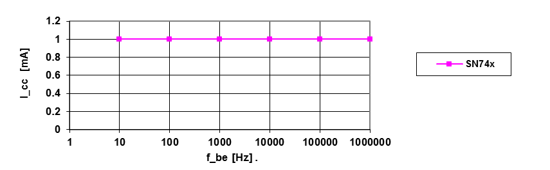CMOS IC:
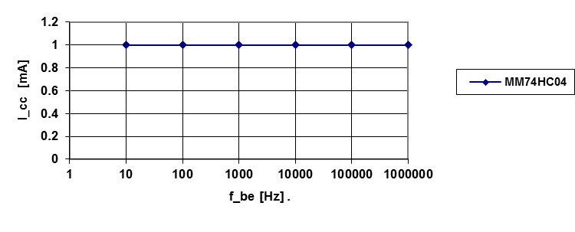
  - Make conclusions on the power consumption of TTL inverters!
<your comments>
  - Make conclusions on the power consumption of CMOS inverters!
<your comments>
- Measurement of delays
  - The measurement setup is the same as the previous exercise, except connect a 10 gate load to the last (6th) inverter. Use the Agilent 33220 function generator to create a 0V to 5V square wave at the frequency of 100 Hz. Measure the generated signal before connecting it! Measure the delay at the 6th inverter, and calculate the average delay of one inverter.
    - Perform the measurement task and record your experience in terms of the different IC types!

Type of IC | L-H delay | H-L delay
Type 1

Type 2

Type of IC | fall time | rise time
Type 1

Type 2

    - Connect a 1nF-capacitive load to the first inverter and perform the above measurement for different IC types. What are the effects of the capacitive load on the first inverter?
<your comments>
- Measurements on D Flip-flop (SN7474)
  - Insert a flip-flop IC to the flip-flop socket on the middle of the evaluation board. Identify the pins of the flip-flop by using the pin setup diagram at the back of this report!
  - Design and implement measurement setup for the propagation time measurements by using the embedded pulse generator block of the evaluation board! (Do not forget the 10 gate load!)
<your comments>
Auxiliary measurement exercises
- Complementary measurement task for measurement point 4
  - Design and implement measurement setups for setup time, hold time measurements by using the embedded pulse generator block of the evaluation board! (Do not forget the 10 gate load!
<your comments>
- Measure the load and supply voltage dependence of the power consumption of logic circuits. (Complementary for exercise two)
  - Connect a capacitive load to the first inverter and perform the power consumption measurement described at exercise 2.
type of IC | 100 Hz | 1 kHz | 10 kHz | 100 kHz | 500 kHz
SN7404N

MM74HC04

<your comments>
  - Measure the power supply voltage dependence of CMOS logic circuits. Use the measurement setup described at exercise 2, with the input signal frequency of 1MHz. Reduce the power supply voltage from 5V to 4.5V, 4V, 3.5V and measure the power consumption of the logic circuit. Do not forget the measure the base power consumption of the Evaluation board each time before calculating the inverter circuit power consumption! Do not raise the power supply voltage above 5V!
Type of IC | 5V | 4.5V | 4V | 3.5V | 3V
MM74C04N

