Laboratory report
Subject of the exercise: | Testing instrumentation amplifiers (Exercise 6.)
Date: | <year>. <month>. <day>
Students name: | <name 1>  <name 2>  <name 3>
Course and group No. | Course: <Course No>, <Group No.>
Supervisors: | <name 1>, <name 2>
Desk No.:
Measurement Tasks
1. Analysis of the DC properties
1.1. Measuring and setting the input offset.
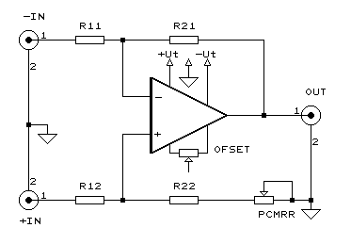 | R₁₁ is [,,,] , value, tolerance  R₁₂ is [,,,] , value, tolerance  R₂₁ is [,,,] , value, tolerance  R₂₂ is [,,,] , value, tolerance
1.1.1. Having short-circuited the resistances R₂₁ and R₂₂, measure with the DC voltmeter the output voltage of the amplifier, then adjust it by means of the potentiometer POFSET to zero.
1.1.2. Leave the inputs of the amplifier free and make the measurement with a resolution of at least 10 μV.
1.1.3. Remove the short-circuits on by one and repeat the measurement of the output voltage. From the measured data determine by calculation the input (bias) current and offset current of the amplifier.

Measured values:
When the R₂₁ is 1 M Ω, then V_{out} = … mV
When the R₂₂ is 1 M Ω, then V_{out} = … mV

I_{bias+} , I_{bias-_,} I_{IO}
...
1.1.4. Set a voltage gain of about A_{v}=100. Having connected the resistances R₁₁ and R₁₂ to ground, measure the output offset voltage, calculate the actual reduced input offset voltages of the inverting and the non-inverting amplifiers. Then – using the potentiometer POFSET – adjust the output offset voltage to zero.

Measured values:
When the R₁₁ and R₁₂ are on the ground, then V_{out} = … mV

V_{reduced_input} = …

1.2. How the offset voltage depends on the supply voltage?
1.2.1. Change the supply voltages symmetrically an asymmetrically by about ±20%. Determine the offset voltage as a function of the supply voltage.

V_{Supply+} [V] | V_{Supply-} [V] | V_{Offset} [mV]

1.3. Determining the Slew Rate and the maximum output voltage
1.3.1. In the case of the gain given in 1.1.4, connect a square-wave signal of 20 kHz on the input of the amplifier and increase it so that the amplifier becomes overdriven. Measure the maximum output voltage swing (V_{outpp} [V]) and the slope of the output signal (SR [V/μs]).
1.4. Determining the limit frequency (and the frequency response) of the maximum output voltage swing 1.4.1. With the value of the Slew Rate determined in the previous paragraph, calculate the limit frequency of the amplifier belonging to the output voltage of V_{out}=10 V_{p} (7.07 V_{eff}) and measure it also by an oscilloscope.
1.5. Determining the maximum output current and the output resistance of the amplifier without feedback.
1.5.1. Load the output of the amplifier with a resistance of R _{L}=1000 Ω and increasing the input voltage at a frequency of f =1 kHz gradually, measure the maximum output voltage of the feedback amplifier (V_{outmax} [V_{p}]).
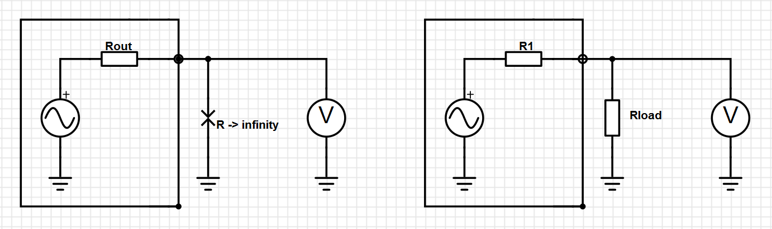
As generally you can calculate the output resistance the next way..
,
But you have to know, the output resistance of the op-amp depends on the feedback! That’s way you have to measure it other way.
where AB is the loop gain. (A = open-loop gain, B = feedback factor)
1.5.2. Measure the maximum output voltage with open circuit load (V_{outomax} [V_{p}]). From the results of the two measurements calculate the output resistance of the amplifier without feedback. Check the result in the catalogue.
V_{outmax} = ….V_{p} Rload = 1000 Ω Rout = …. Ω

2. Analysis of the dynamic features
2.1. Measuring the Bode plot of an inverting amplifier (A(f))_{v}
2.1.1. Connect the output of the sine-wave generator to the inverting input of the instrumentation amplifier and connect the non-inverting input to ground. Measure input and output voltages and the phase shift of the amplifier with an oscilloscope. Make the measurement in the following way: at a frequency of 1 kHz set an output voltage 7 V_{eff} (0 dB) using the AC voltmeter, then changing the frequency in the range 1 Hz – 1 MHz in 1-2-5-10 steps, measure the effective value of the input and the output voltages and the phase shift. On the base of the measured data calculate and plot the Bode diagram of the inverting amplifier.

2.1.2. Determine the limit frequency of the amplifier belonging to a decrease of -3 dB.

2.2. Measuring the common mode gain of an instrumentation amplifier (A(f)_{vc})
2.2.1. Apply a short circuit between the inputs of the instrumentation amplifier and give a sine-wave of 3 V_{eff} between the short circuit and the ground. Measure the input and output voltages and the phase shift using an oscilloscope and an AC voltmeter.

2.2.2. In the reference branch, by means of the potentiometer PCMRR, which is series connected to the resistance R22, set the minimum of the common mode voltage gain at a frequency of f = 10 Hz and measure this common gain.
2.2.3. Take the Bode diagram of the common mode voltage gain of the instrumentation amplifier and plot it in the frequency range of 10 Hz-1 MHz.
2.3. Measuring the Bode diagram of a non-inverting instrumentation amplifier (A(f)_{v})
2.3.1. Connect the output of the sine-wave generator to the non-inverting input of the instrumentation amplifier and connect the inverting input to ground. Measure the input and output voltages and the phase shift of the amplifier by means of an oscilloscope and an AC voltmeter.
2.3.2. Take the Bode diagram of the non-inverting amplifier at the same frequencies and input amplitudes, which were used in case of the Bode diagram measurement of the inverting amplifier. Plot the results of the measurement in a common diagram with the Bode diagram of the inverting amplifier.

