Measurement results for Laboratory exercises 2, Exercise 6 „Testing instrumentation amplifiers”
You should select the measurement results for the specific measurement tasks according to your Neptun code as given in the following descriptions.

Output voltage values of the amplifier
If the first letter of your Neptun code is: '0', '5', 'A', 'F', 'K', 'P', 'U', 'Z'
U1 ⇒ U_{kioffset} = 0 µV
If the first letter of your Neptun code is: '1', '6', 'B', 'G', 'L', 'Q', 'V'
U2 ⇒ U_{kioffset} = -2 µV
If the first letter of your Neptun code is: '2', '7', 'C', 'H', 'M', 'R', 'W'
U3 ⇒ U_{kioffset} = 6 µV
If the first letter of your Neptun code is: '3', '8', 'D', 'I', 'N', 'S', 'X'
U4 ⇒ U_{kioffset} = 10 µV
If the first letter of your Neptun code is: '4', '9', 'E', 'J', 'O', 'T', 'Y'
U5 ⇒ U_{kioffset} = -11 µV

Output offset voltage values
If the second letter of your Neptun code is: '0', '5', 'A', 'F', 'K', 'P', 'U', 'Z'
U1 ⇒ U_{+kiOff} = -40 µV U_{-kiOff} = 35 µV
If the second letter of your Neptun code is: '1', '6', 'B', 'G', 'L', 'Q', 'V'
U2 ⇒ U_{+kiOff} =-39 µV U_{-kiOff} = 34 µV
If the second letter of your Neptun code is: '2', '7', 'C', 'H', 'M', 'R', 'W'
U3 ⇒ U_{+kiOff} = -33 µV U_{-kiOff} = 42 µV
If the second letter of your Neptun code is: '3', '8', 'D', 'I', 'N', 'S', 'X'
U4 ⇒ U_{+kiOff} = -28 µV U_{-kiOff} = 46 µV
If the second letter of your Neptun code is: '4', '9', 'E', 'J', 'O', 'T', 'Y'
U5 ⇒ U_{+kiOff} = -48 µV U_{-kiOff} = 26 µV

Output offset voltage for the calculation of input offset voltages
If the third letter of your Neptun code is: '0', '5', 'A', 'F', 'K', 'P', 'U', 'Z'
U1 ⇒ U_{kiOffset} = 110 µV
If the third letter of your Neptun code is: '1', '6', 'B', 'G', 'L', 'Q', 'V'
U2 ⇒ U_{kioffset} = -180 µV
If the third letter of your Neptun code is: '2', '7', 'C', 'H', 'M', 'R', 'W'
U3 ⇒ U_{kioffset} = 550 µV
If the third letter of your Neptun code is: '3', '8', 'D', 'I', 'N', 'S', 'X'
U4 ⇒ U_{kioffset} = 830 µV
If the third letter of your Neptun code is: '4', '9', 'E', 'J', 'O', 'T', 'Y'
U5 ⇒ U_{kioffset} = -670 µV

Measurement of the gain of the inverting amplifier
If the fourth letter of your Neptun code is: '0', '5', 'A', 'F', 'K', 'P', 'U', 'Z'
Signal 1:
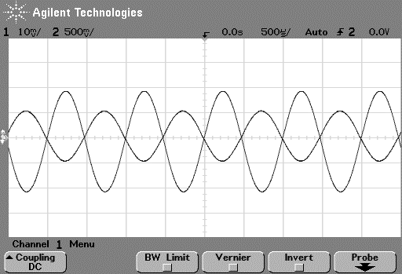
If the fourth letter of your Neptun code is: '1', '6', 'B', 'G', 'L', 'Q', 'V'
Signal 2:
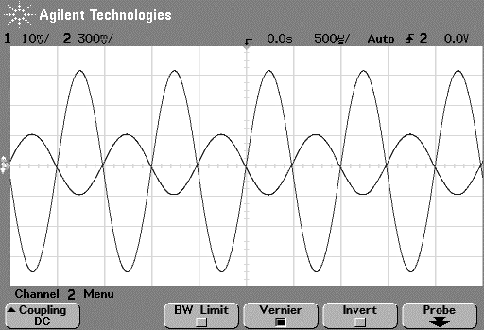
If the fourth letter of your Neptun code is: '2', '7', 'C', 'H', 'M', 'R', 'W'
Signal 3:
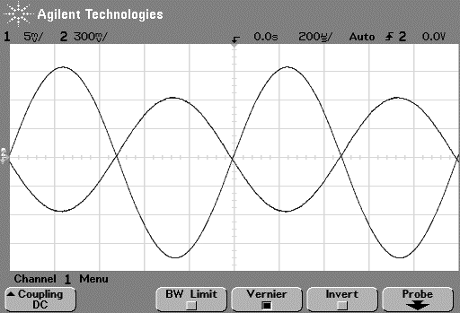
If the fourth letter of your Neptun code is: '3', '8', 'D', 'I', 'N', 'S', 'X'
Signal 4:
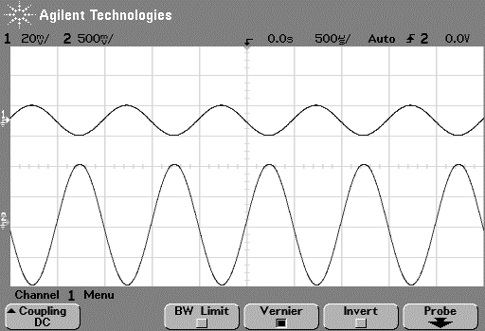
If the fourth letter of your Neptun code is: '4', '9', 'E', 'J', 'O', 'T', 'Y'
Signal 5:
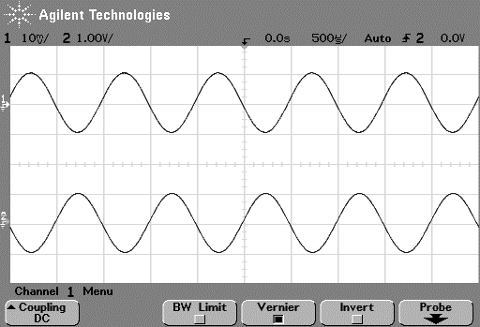

Results for measuring the slew-rate of the inverting amplifier
If the fifth letter of your Neptun code is: '0', '5', 'A', 'F', 'K', 'P', 'U', 'Z'
Signal 1:
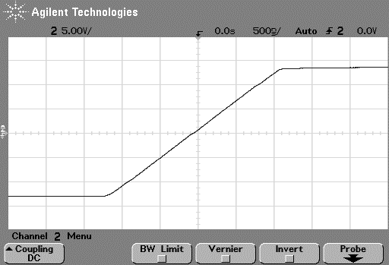
If the fifth letter of your Neptun code is: '1', '6', 'B', 'G', 'L', 'Q', 'V'
Signal 2:
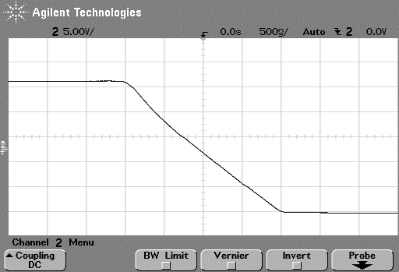
If the fifth letter of your Neptun code is: '2', '7', 'C', 'H', 'M', 'R', 'W'
Signal 3:
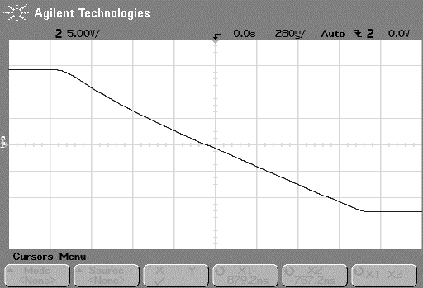
If the fifth letter of your Neptun code is: '3', '8', 'D', 'I', 'N', 'S', 'X'
Signal 4:
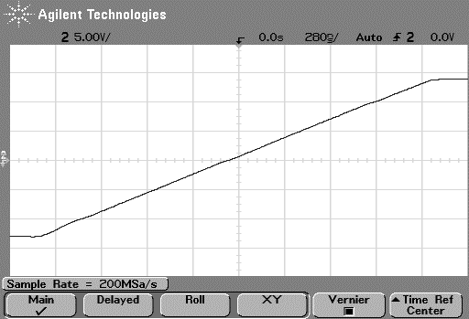
If the fifth letter of your Neptun code is: '4', '9', 'E', 'J', 'O', 'T', 'Y'
Signal 5:
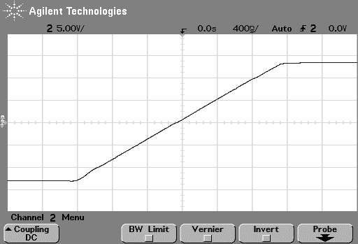

Output waveform for sine wave at frequency f_{kv}
If the sixth letter of your Neptun code is: '0', '5', 'A', 'F', 'K', 'P', 'U', 'Z'
Signal 1:
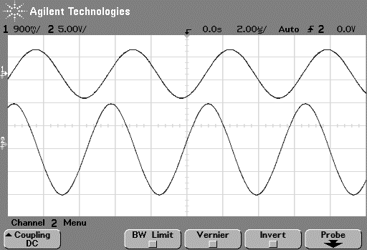
If the sixth letter of your Neptun code is: '1', '6', 'B', 'G', 'L', 'Q', 'V'
Signal 2:
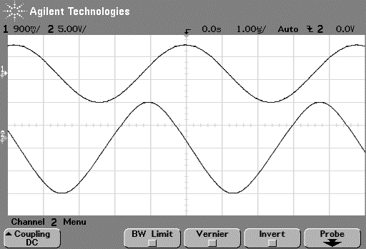
If the sixth letter of your Neptun code is: '2', '7', 'C', 'H', 'M', 'R', 'W'
Signal 3:
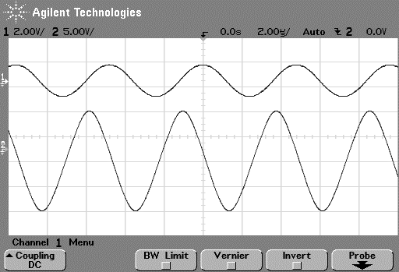
If the sixth letter of your Neptun code is: '3', '8', 'D', 'I', 'N', 'S', 'X'
Signal 4:
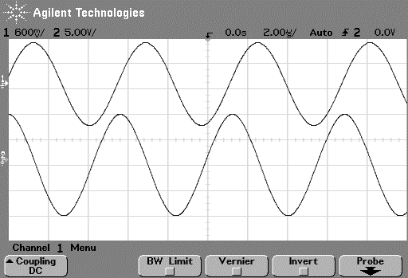
If the sixth letter of your Neptun code is: '4', '9', 'E', 'J', 'O', 'T', 'Y'
Signal 5:
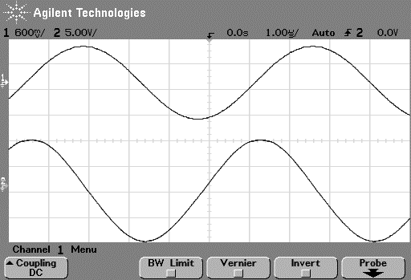

Measurement results for amplitude and phase characteristics of the inverting amplifier
If the first letter of your Neptun code is: '0', '5', 'A', 'F', 'K', 'P', 'U', 'Z'
Bode01_Eredmeny.xlsx
If the first letter of your Neptun code is: '1', '6', 'B', 'G', 'L', 'Q', 'V'
Bode02_Eredmeny.xlsx
If the first letter of your Neptun code is: '2', '7', 'C', 'H', 'M', 'R', 'W'
Bode03_Eredmeny.xlsx
If the first letter of your Neptun code is: '3', '8', 'D', 'I', 'N', 'S', 'X'
Bode04_Eredmeny.xlsx
If the first letter of your Neptun code is: '4', '9', 'E', 'J', 'O', 'T', 'Y'
Bode05_Eredmeny.xlsx

Measurement results for the common mode gain measurement
If the second letter of your Neptun code is: '0', '5', 'A', 'F', 'K', 'P', 'U', 'Z'
Signal 1:
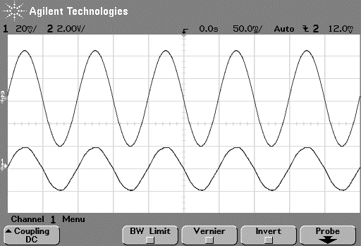
If the second letter of your Neptun code is: '1', '6', 'B', 'G', 'L', 'Q', 'V'
Signal 2:
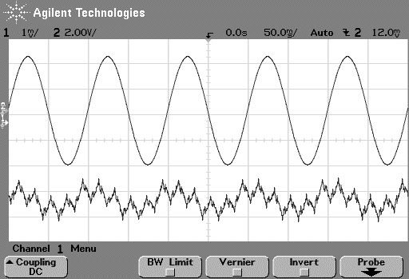
If the second letter of your Neptun code is: '2', '7', 'C', 'H', 'M', 'R', 'W'
Signal 3:
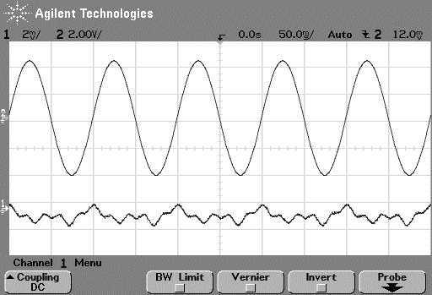
If the second letter of your Neptun code is: '3', '8', 'D', 'I', 'N', 'S', 'X'
Signal 4:
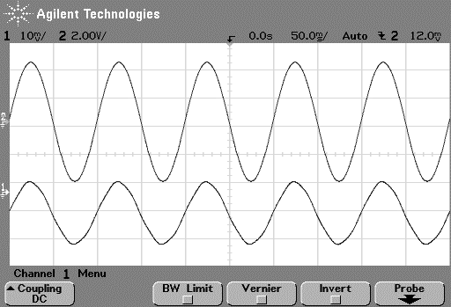
If the second letter of your Neptun code is: '4', '9', 'E', 'J', 'O', 'T', 'Y'
Signal 5:
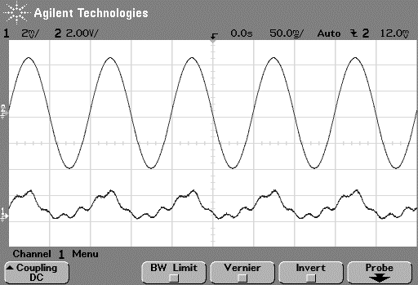

Measuring the common mode amplitude and phase characteristics
If the third letter of your Neptun code is: '0', '5', 'A', 'F', 'K', 'P', 'U', 'Z'
Bode01_Eredmeny.xlsx
If the third letter of your Neptun code is: '1', '6', 'B', 'G', 'L', 'Q', 'V'
Bode02_Eredmeny.xlsx
If the third letter of your Neptun code is: '2', '7', 'C', 'H', 'M', 'R', 'W'
Bode03_Eredmeny.xlsx
If the third letter of your Neptun code is: '3', '8', 'D', 'I', 'N', 'S', 'X'
Bode04_Eredmeny.xlsx
If the third letter of your Neptun code is: '4', '9', 'E', 'J', 'O', 'T', 'Y'
Bode05_Eredmeny.xlsx

Measurement results for noninverting amplifier’s amplitude and phase characteristics
If the fourth letter of your Neptun code is: '0', '5', 'A', 'F', 'K', 'P', 'U', 'Z'
Bode01_Eredmeny.xlsx
If the fourth letter of your Neptun code is: '1', '6', 'B', 'G', 'L', 'Q', 'V'
Bode02_Eredmeny.xlsx
If the fourth letter of your Neptun code is: '2', '7', 'C', 'H', 'M', 'R', 'W'
Bode03_Eredmeny.xlsx
If the fourth letter of your Neptun code is: '3', '8', 'D', 'I', 'N', 'S', 'X'
Bode04_Eredmeny.xlsx
If the fourth letter of your Neptun code is: '4', '9', 'E', 'J', 'O', 'T', 'Y'
Bode05_Eredmeny.xlsx

