Measurement results of measurement no. 4: Electric power measurement

You have to choose a dataset for each measurement based on a given character in your Neptun-code.

Exercise M4 - 2. (Measurement of active and reactive power of an RLC circuit supplied with sinusoidal AC voltage)
The measurement was conducted with an oscilloscope. Each screenshot contains the voltage and the current waveforms. To tell the difference between voltage and current you have to note that the trigger is set to the rising edge of the voltage signal, so the voltage has zero-crossing at t=0.0 s.
Vertical and horizontal scales can be read from the screenshots.

If the first character of your Neptun-code is '0', '5', 'A', 'F', 'K', 'P', 'U', 'Z', the you should use:
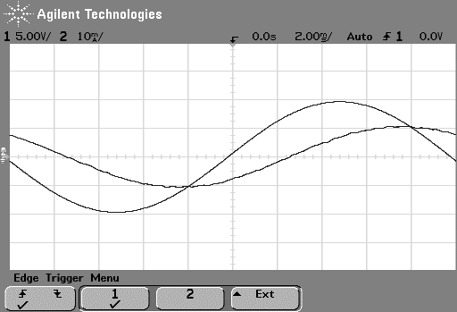

If the first character of your Neptun-code is '1', '6', 'B', 'G', 'L', 'Q', 'V', then you should use:

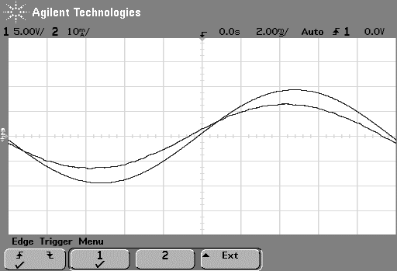

If the first character of your Neptun-code is '2', '7', 'C', 'H', 'M', 'R', 'W', then you should use:

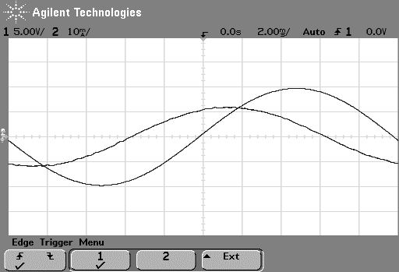

If the first character of your Neptun-code is '3', '8', 'D', 'I', 'N', 'S', 'X', then you should use:

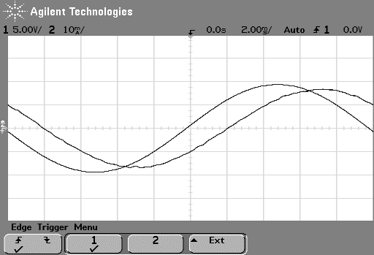

If the first character of your Neptun-code is '4', '9', 'E', 'J', 'O', 'T', 'Y', then you should use:

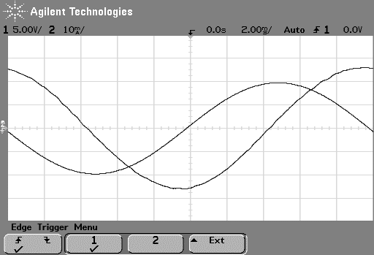

Exercise M4 - 3. (Measurement of active and reactive power of an RLC circuit supplied with general waveform AC voltage)

If the first character of your Neptun-code is '0', '5', 'A', 'F', 'K', 'P', 'U', 'Z', then you should use:

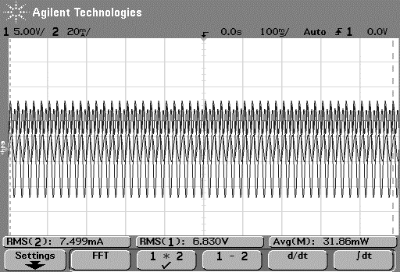

If the first character of your Neptun-code is '1', '6', 'B', 'G', 'L', 'Q', 'V', then you should use:

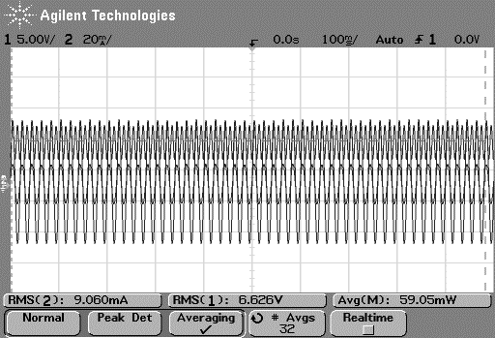

If the first character of your Neptun-code is '2', '7', 'C', 'H', 'M', 'R', 'W', then you should use:

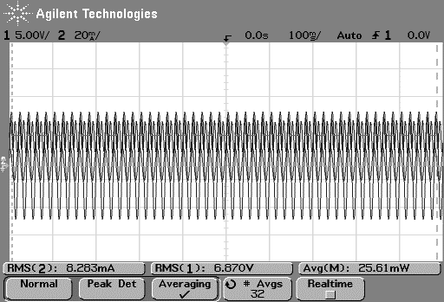

If the first character of your Neptun-code is '3', '8', 'D', 'I', 'N', 'S', 'X', then you should use:

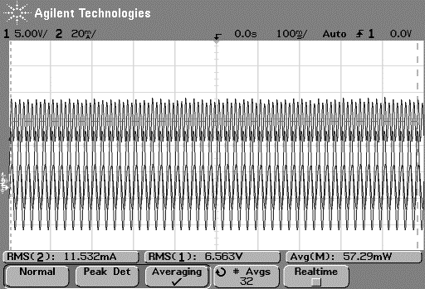

If the first character of your Neptun-code is '4', '9', 'E', 'J', 'O', 'T', 'Y', then you should use:

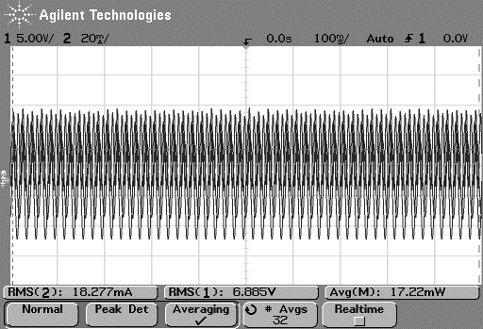

Exercise M4 - 4. (Measurement of active and reactive power of an RLC circuit supplied with an AC power supply)

If the second character of your Neptun-code is '0', '5', 'A', 'F', 'K', 'P', 'U', 'Z', then you should use:

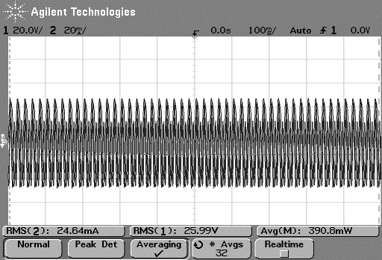

U | I | P | Q | cos $ϕ$
25.9 V | 0.024 A | 0.375 W | 0.489 var | 0.58

If the second character of your Neptun-code is '1', '6', 'B', 'G', 'L', 'Q', 'V', then you should use:

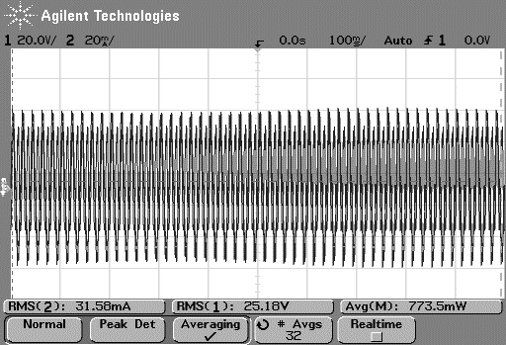

U | I | P | Q | cos $ϕ$
25.5 V | 0.033 A | 0.793 W | 0.181 var | 0.95

If the second character of your Neptun-code is: '2', '7', 'C', 'H', 'M', 'R', 'W', then you should use

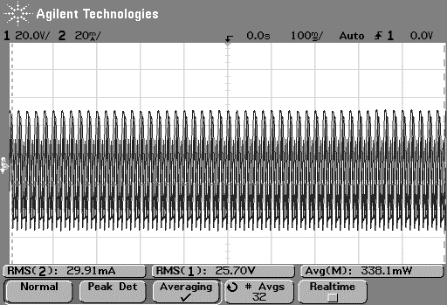

U | I | P | Q | cos $ϕ$
25.6 V | 0.030 A | 0.354 W | -0.687 var | 0.54

If the second character of your Neptun-code is '3', '8', 'D', 'I', 'N', 'S', 'X', then you should use:
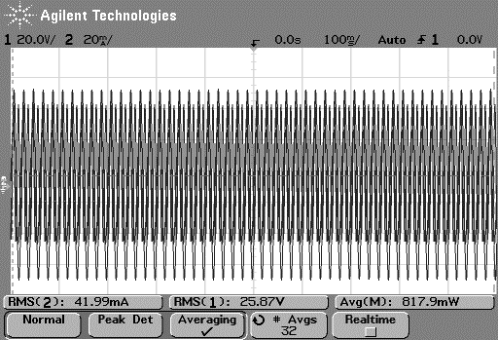

U | I | P | Q | cos $ϕ$
25.8 V | 0.043 A | 0.811 W | 0.742 var | 0.70

If the second character of your Neptun-code is '4', '9', 'E', 'J', 'O', 'T', 'Y', then you should use

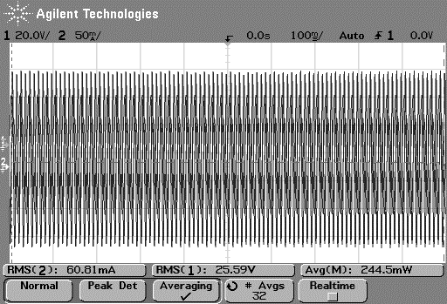

U | I | P | Q | cos $ϕ$
25.5 V | 0.061 A | 0.210 W | 1.544 var | 0.09

Exercise M4 - 5. (Measurement of active and reactive power consumption of light sources supplied from the mains)

Characteristics of halogen bulb

If the third character of your Neptun-code is '0', '3', '6', '9', 'C', 'F', 'I', 'L', 'O', 'R', 'U', 'X', then you should use:

Halogen 1
Power-meter:

U₁ (V) | I₁ (A) | P₁ (W) | cos(fi)₁
20 | 0,057 | 1,15 | 1
80 | 0,111 | 8,91 | 1
140 | 0,148 | 20,8 | 1
200 | 0,180 | 36,2 | 1
230 | 0,195 | 45,1 | 1

Oscilloscope:

U₂ (V) | I₂ (A) | P₂ (W) | cos(fi)₂
19,6 | 0,057 | 1,11 | 0,99
79,9 | 0,110 | 8,77 | 1,00
139,6 | 0,146 | 20,3 | 1,00
198,8 | 0,177 | 35,1 | 1,00
228,5 | 0,192 | 43,6 | 0,99

If the third character of your Neptun-code is '1', '4', '7', 'A', 'D', 'G', 'J', 'M', 'P', 'S', 'V', 'Y', then you should use

Halogen 2
Power-meter:

U₁ (V) | I₁ (A) | P₁ (W) | cos(fi)₁
40,3 | 0,078 | 3,16 | 1
100 | 0,124 | 12,40 | 1
160 | 0,159 | 25,8 | 1
220 | 0,190 | 42,2 | 1
230 | 0,195 | 45,1 | 1

Oscilloscope:

U₂ (V) | I₂ (A) | P₂ (W) | cos(fi)₂
40,2 | 0,077 | 3,10 | 1,00
99,0 | 0,122 | 11,90 | 0,99
159,8 | 0,158 | 25,1 | 0,99
218,7 | 0,187 | 40,8 | 1,00
228,5 | 0,192 | 43,6 | 0,99

If the third character of your Neptun-code is '2', '5', '8', 'B', 'E', 'H', 'K', 'N', 'Q', 'T', 'W', 'Z', then you should use:

Halogen 3
Power- meter:

U₁ (V) | I₁ (A) | P₁ (W) | cos(fi)₁
20 | 0,057 | 1,15 | 1
60 | 0,095 | 5,74 | 1
120 | 0,137 | 16,43 | 1
180 | 0,170 | 31,0 | 1
230 | 0,195 | 45,1 | 1

Oscilloscope:

U₂ (V) | I₂ (A) | P₂ (W) | cos(fi)₂
19,6 | 0,057 | 1,11 | 0,99
60,1 | 0,094 | 5,67 | 1,00
119,5 | 0,134 | 16,00 | 1,00
180,1 | 0,168 | 30,2 | 1,00
228,5 | 0,192 | 43,6 | 0,99

Characteristics of the compact fluorescent bulb or the LED

If the fourth character of your Neptun-code is '0', '6', 'C', 'I', 'O', 'U', then you should use:

Fluorescent 1
Power-meter

U₁ (V) | I₁ (A) | P₁ (W) | cos(fi)₁
20 | 0 | 0 | NaN
65 | 0,061 | 2,72 | NaN
100 | 0,067 | 4,34 | 0,98
160 | 0,063 | 6,69 | 0,98
230 | 0,071 | 10,20 | 0,98

Oscilloscope:

U₂ (V) | I₂ (A) | P₂ (W) | cos(fi)₂
19,8 | 0,000 | 0 | NaN
64,8 | 0,057 | 2,65 | 0,72
99,4 | 0,061 | 4,21 | 0,69
159,1 | 0,060 | 6,44 | 0,67
225,9 | 0,065 | 9,45 | 0,64

If the fourth character of your Neptun-code is '1', '7', 'D', 'J', 'P', 'V', then you should use:

Fluorescent 2
Power-meter:

U₁ (V) | I₁ (A) | P₁ (W) | cos(fi)₁
40,3 | 0 | 0 | NaN
65 | 0,061 | 2,72 | NaN
120 | 0,073 | 5,28 | 0,98
180 | 0,063 | 7,42 | 0,98
230 | 0,071 | 10,20 | 0,98

Oscilloscope:

U₂ (V) | I₂ (A) | P₂ (W) | cos(fi)₂
40,3 | 0,000 | 0 | NaN
64,8 | 0,057 | 2,65 | 0,72
119,4 | 0,062 | 5,20 | 0,70
180,5 | 0,060 | 7,17 | 0,66
225,9 | 0,065 | 9,45 | 0,64

If the fourth character of your Neptun-code is '2', '8', 'E', 'K', 'Q', 'W', then you should use:

Fluorescent 3
Power-meter:

U₁ (V) | I₁ (A) | P₁ (W) | cos(fi)₁
40,3 | 0 | 0 | NaN
80 | 0,064 | 3,37 | NaN
140 | 0,069 | 6,11 | 0,98
200 | 0,066 | 8,37 | 0,98
230 | 0,071 | 10,20 | 0,98

Oscilloscope:

U₂ (V) | I₂ (A) | P₂ (W) | cos(fi)₂
40,3 | 0,000 | 0 | NaN
79,6 | 0,060 | 3,26 | 0,68
140,1 | 0,064 | 5,92 | 0,66
198 | 0,063 | 8,40 | 0,67
225,9 | 0,065 | 9,45 | 0,64

If the fourth character of your Neptun-code is '3', '9', 'F', 'L', 'R', 'X', then you should use:

LED 1
Power-meter:

U₁ (V) | I₁ (A) | P₁ (W) | cos(fi)₁
20 | 0,000 | 0 | NaN
60 | 0,070 | 3,77 | NaN
100 | 0,076 | 4,90 | 0,98
160 | 0,060 | 5,80 | 0,98
230 | 0,043 | 5,96 | 0,98

Oscilloscope:

U₂ (V) | I₂ (A) | P₂ (W) | cos(fi)₂
19,8 | 0,000 | 0 | NaN
59,9 | 0,068 | 3,70 | 0,91
100,3 | 0,073 | 4,75 | 0,65
159,2 | 0,051 | 5,38 | 0,66
225,6 | 0,040 | 5,51 | 0,61

If the fourth character of your Neptun-code is '4', 'A', 'G', 'M', 'S', 'Y', then you should use:

LED 2
Power-meter:

U₁ (V) | I₁ (A) | P₁ (W) | cos(fi)₁
45 | 0,036 | 1,12 | NaN
100 | 0,076 | 4,90 | 0,98
140 | 0,067 | 5,79 | 0,98
180 | 0,050 | 5,81 | 0,98
230 | 0,043 | 5,96 | 0,98

Oscilloscope:

U₂ (V) | I₂ (A) | P₂ (W) | cos(fi)₂
44,8 | 0,032 | 1,08 | 0,75
100,3 | 0,073 | 4,75 | 0,65
139,4 | 0,061 | 5,58 | 0,66
177,7 | 0,048 | 5,53 | 0,65
225,6 | 0,040 | 5,51 | 0,61

If the fourth character of your Neptun-code is '5', 'B', 'H', 'N', 'T', 'Z', then you should use:

LED 3
Power-meter:

U₁ (V) | I₁ (A) | P₁ (W) | cos(fi)₁
45 | 0,036 | 1,12 | NaN
80 | 0,071 | 4,43 | 0,98
120 | 0,081 | 5,77 | 0,98
200 | 0,045 | 5,86 | 0,98
230 | 0,043 | 5,96 | 0,98

Oscilloscope:

U₂ (V) | I₂ (A) | P₂ (W) | cos(fi)₂
44,8 | 0,032 | 1,08 | 0,75
79,5 | 0,069 | 4,30 | 0,78
120,2 | 0,076 | 5,61 | 0,61
198,0 | 0,043 | 5,51 | 0,65
225,6 | 0,040 | 5,51 | 0,61

