Laboratory report
Subject of the exercise: | Building and measuring a simple electronic circuit (Exercise 1.)
Date: | <year>. <month>. <day>
Students name: | <name 1>  <name 2>  <name 3>
Course and group No. | Course: <Course No>, <Group No.>
Supervisors: | <name 1>, <name 2>
Desk No.:
Distance learning
The distance learning laboratory will be hold using the TINA-TI simulator:
https://www.ti.com/tool/TINA-TI
There is a short overview about TINA-TI:
https://www.ti.com/lit/ug/sbou052a/sbou052a.pdf
We created a virtual machine which contains an installed version of TINA-TI (this is the same virtual machine which was used for the OrCAD measurement):
https://www.mit.bme.hu/oktatas/targyak/vimiac13/orcad-virtualis-gep-elerese
Please use NIIF cloud if possible. Please backup your work regularly to your local machine!
Please read the related literature on the homepage:
Basic OPA circuits _ part 3 (Dr. József Zoltai) [comparator, Scmitt-trigger, waveform generator]
http://www.mit.bme.hu/eng/system/files/oktatas/targyak/vedett/11042/Part12-Elec1-non-lin-opampappl.pdf
(protected file, you should log in)

Measurement Tasks
- Build the circuit depicted in fig. 1-1! The parameter values should be determined by the tutor! Integrator: block A, the Schmitt-trigger (comparator): block B
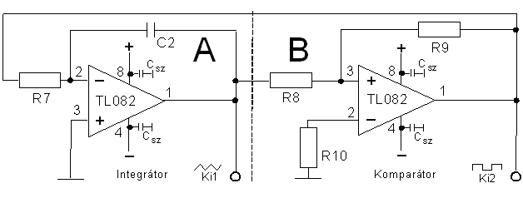
Figure 1-1. Waveform generator
In the simulator, you can use a TL081 type of OPA.
The OPA should have symmetric, ±15 V supply voltage! You can use two separate power supply to ensure positive and negative voltages!
The value of R9 should be 10 kΩ, and R8 should be selected such that the trigger voltage is ±10 V. Build the simulation framework for testing the comparator, and check the trigger levels!
Let C2=100 µF and R2=10 kΩ. Let’s check the waveform of the triangle wave. You should select transient analysis, and the “Zero initial values” option should be set otherwise no oscillation occurs.
After the successful design and building, a triangle signal can be measured on clamp “Ki1” and a square on “Ki2”. The amplitude of the latter one is determined by the saturation voltage of the op-amp. The triangle is determined by the threshold levels of the Schmitt-trigger.
Copy the typical waveforms (Uki1, Uki2) to the report! Explain your experiences!

