Laboratory report
Subject of the exercise: | Building and measuring a simple electronic circuit (Exercise 1.)
Date: | <year>. <month>. <day>
Students name: | <name 1>  <name 2>  <name 3>
Course and group No. | Course: <Course No>, <Group No.>
Supervisors: | <name 1>, <name 2>
Desk No.:
Measurement Tasks
- Basic amplifier circuits
Student A: using the breadboard and the parts obtained from the tutor, build the basic non-inverting amplifier circuit (See fig. 1-1.). The power supply should be ±15 V.
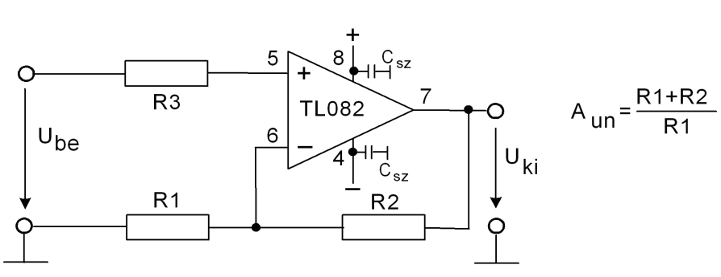
Figure 1-1. Basic non-inverting amplifier circuit
<summarize your results>
Student B: using the breadboard and the parts obtained from the tutor, build the basic inverting amplifier circuit (See fig. 1-2.). The power supply should be ±15 V. Use AC coupling on the input.
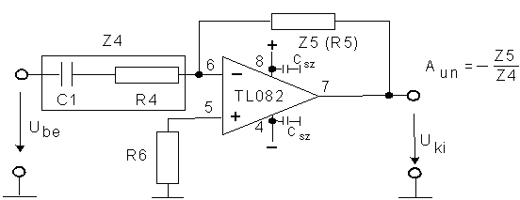
Figure 1-2. Basic inverting amplifier circuit with AC coupling on input
<summarize your results>
- Measurements with the non-inverting amplifier
Double check the value of supply voltages (±15V) and the polarity of connections. Switch on the circuit only if the tutor has checked it.
Measuring the offset voltage of the amplifier (shortcut on the input). Measure the output voltage, if the input voltage is 0 (output offset)! Calculate the input offset! Evaluate the result: What is the reason for offset voltages? Is the measured value plausible (compare with datasheet values)? What is caused by the operation point bias current? How can you select the optimal value for R3?
Measurement of the saturation voltages: Trace the output by means of oscilloscope. Increase the input amplitude until the output distortion is notable. After that, decrease the amplitude until the distortion disappears. Measure the input and output voltages (RMS and PP values)!
Measure the voltage gain!
<summarize your results>

- Measurements with the inverting amplifier
Measure the voltage gain at 1 kHz!
Examine the impulse transfer! Measure rise- and fall-time, over- and undershoot!
Compare the large- and small-signal operation!
Calculate the slew-rate of the op-amp!
<summarize your results>

Supplementary Measurement task
- Waveform generator
Build the circuit depicted in fig. 1-3! The parameter values should be determined by the tutor! (The integrator should be built by student A, the Schmitt-trigger (comparator) by student B)
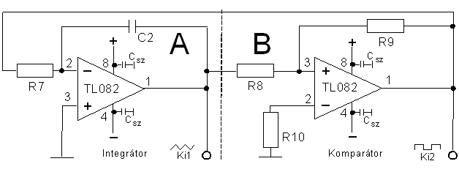
Figure 1-3. Waveform generator
Build the Waveform generator: connect the comparator output to the integrator input. Double check the power supply (±15 V)! Switch on the circuit only if the tutor has checked it.
After the successful design and building, a triangle signal can be measured on clamp “Ki1” and a square on “Ki2”. The amplitude of the latter one is determined by the saturation voltage of the op-amp. The triangle is determined by the threshold levels of the Schmitt-trigger.
Copy the typical waveforms (U_{ki1}, U_{ki2}) to the protocol!

