Exercise Report (Distance Education)  
(Lab2-M10)

|  |  |
| --- | --- |
| **Subject of this exercise:** | Performance Evaluation of a 915-MHz FSK SoC Radio Transceiver |
| **Students – Student code:** | <me>-student code  <myself> -student code  <I> -student code |
| **Course/code:** | <course>, <group> |
| **Date & time:** | 20<YY>. <MM>. <DD>. |
| **Lecturer today:** |  |

Measuring equipment used: the photos of the instruments can be found at the end of the document!

|  |  |
| --- | --- |
| Oscilloscope | Agilent 54622A |
| Spectrum Analyzer | Agilent E4411B ESA-L |
| RF Signal Generator | Agilent E4430B ESG-D |
| Power Supply | Agilent E3630 |
| Function Generator | Agilent 33220A |
| Digital Multimeter (6½ digit) | Agilent 3440A |

Video hints available online (link address has to be copied):

1. RF Signal Generator: https://web.microsoftstream.com/video/184a5335-42ca-47cb-8467-79c62712cd1b
2. Oscilloscope: https://web.microsoftstream.com/video/e59ea123-b26c-4000-a10e-54cec1dc23de
3. RF Spectrum Analyser: https://web.microsoftstream.com/video/3f8f32ae-dc7f-4820-be15-8451c77f5cd4
4. TRF6900A Evaluation Module: https://web.microsoftstream.com/video/ac02d7a8-7a3a-489e-bc1d-b09df97be542
5. TRF6900A Control SW: https://web.microsoftstream.com/video/0596a0e7-382b-4d2e-934c-739db75c8f8b

If the upper links won’t work use the following alternative to download all in one zipped file: http://home.mit.bme.hu/~krebesz/english_video.zip

Exercises

1. First use of the RF measuring instruments (see video hints A., B. and C.)
   1. AM modulated signal generated by the RF signal generator is examined with the following parameters: carrier frequency=1 MHz, power level=0 dBm, AM modulation with modulating frequency=10 kHz and modulation index=10%.
   2. Draw the block diagram of the measurement configuration used to measure the AM signal and its components (carrier and modulating signal) in the time domain (the photos of the instruments at the end of the document and the drawing capabilities of MS-Word can be used).

<Experience collected during the completion of the measurement>

* 1. Based on the measurement results below and the task description explain what is seen on the instrument display by answering the following question:
     + - The display seen belongs to which measuring instrument and generally used for what?
       - What is the frequency of the signal at Channel 1?
       - What is the frequency of the signal at Channel 2?
       - Which signal is the modulated carrier and the modulating signal (use Channel number for identification)
       - Which channel is used for triggering?
       - What kind of modulation can be seen and how is it mapped into the signals?

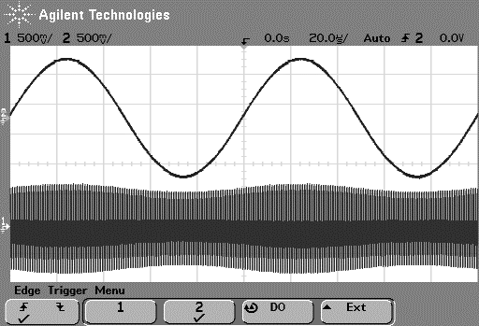

<Experience collected during the completion of the measurement>

* 1. Draw the block diagram of the measurement used to measure the AM signal and its components (carrier and modulating signal) in the frequency domain (the photos of the instruments at the end of the document and the drawing capabilities of MS-Word can be used).
  2. Examine the spectrum of the AM modulated signal applying various RBW[1] (2 different values: 1kHz/3kHz), VBW[2] (2 different values: 30Hz/300Hz) and SPAN[3] (as given: 100kHz) parameters of RF spectrum analyzer by answering the following questions and having the following measurement results:
* The display seen belongs to which measuring instrument and generally used for what?
* How do we know based on the measurement results that an AM signal is measured?
* What is the role of Resolution BandWidth (RBW) parameter in the operation of the spectrum analyser?
* What is the role of Video BandWidth (VBW) parameter in the operation of the spectrum analyser?
* What is Center Frequency, its value in this measurement and why that value is chosen?
* What is Span, its value in this measurement and why that value is chosen?
* Draw the consequences of how the measuremnt results are influenced by the values of VBW and RBW?
* What is sweep time and how it related to the parameters VBW and RBW?



<Experience collected during the completion of the measurement>

2 Generation of an unmodulated signal with the TRF6900A transmitter   
(see video hints D. and E.)

* 1. This measurement point is about he evaluation board[4] and the TRF6900A.exe control software.
* Suggested settings
  + Power supply: 8.5VDC
  + Desired frequency = 915.199921 MHz

(output frequency at the chip – in the TRF6900A control SW push *Send Words Now* (F12) button to activate the settings)

* + SPAN = 200 kHz
  + RBW = 1 kHz
  + VBW = 30 Hz

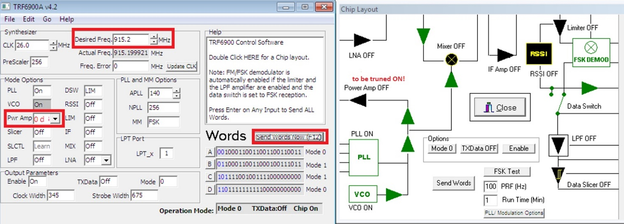

* 1. Draw the block diagram of the measurement configuration to be used to measure the output signal of the evaluation board RF transmitter in the frequency domain (the photos of the instruments at the end of the document and the drawing capabilities of MS-Word can be used.)
  2. The following spectrum can be measured at the output of the evaluation board RF transmitter:

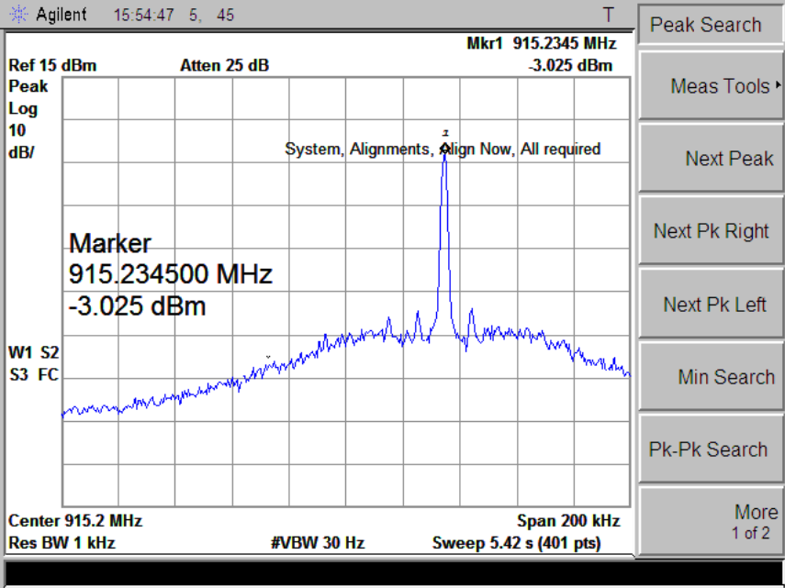

* Based on the measurement result determine the actual value of the output frequency!
* Does the measurement result meet the expectation?

<Experience collected during the completion of the measurement>

* 1. Correct the error in clock frequency using the TRF6900A software!

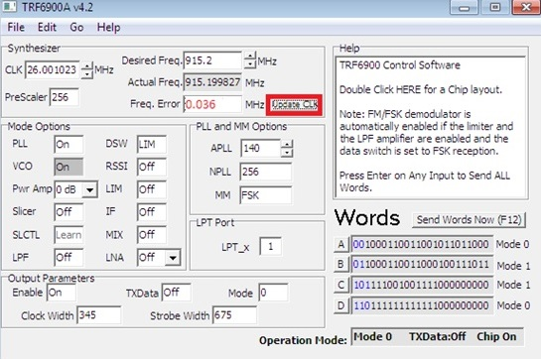

* What are the sources of this error?
* On the above spectrum mark (put an „x” on the display) the signal appearance (frequency and power level) after frequency compensation!

<Experience collected during the completion of the measurement>

* 1. Based on the following measurement results record the actual value of the output power level in dBm at each Pwr Amp[5] settings and determine the values of real attenuations. Do not forget the units after the values! Use the table below!

Pwr Amp=Off:

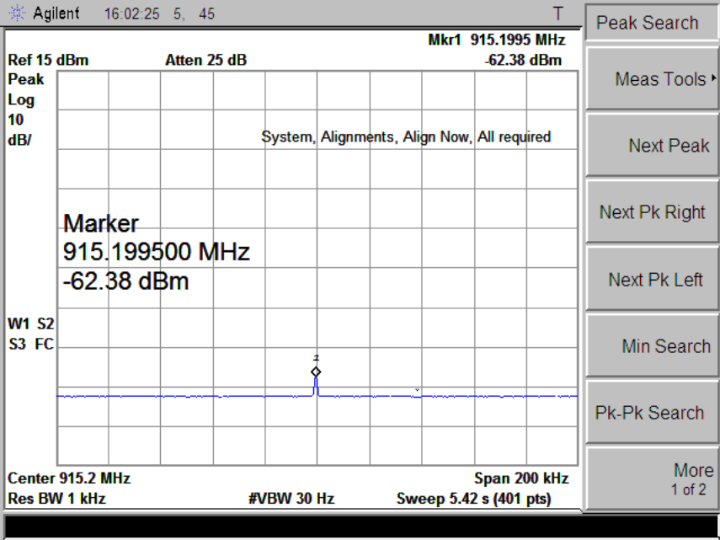

Pwr Amp=20dB attenuation:

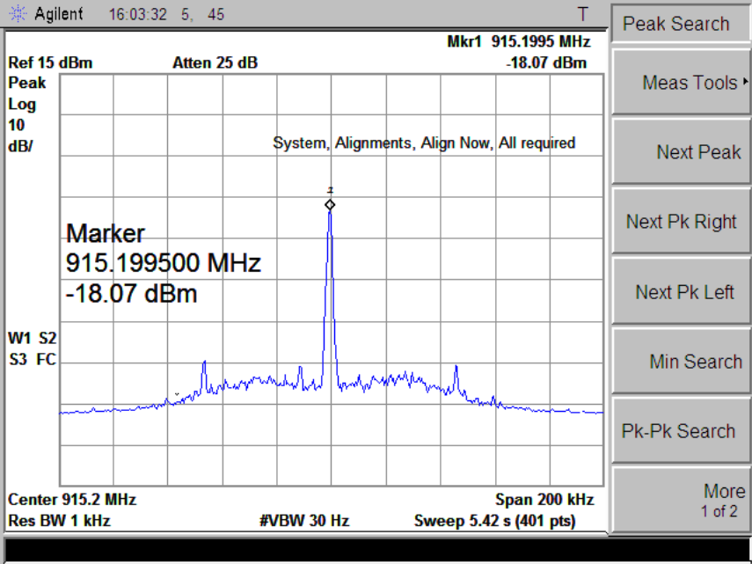

Pwr Amp=10dB attenuation:

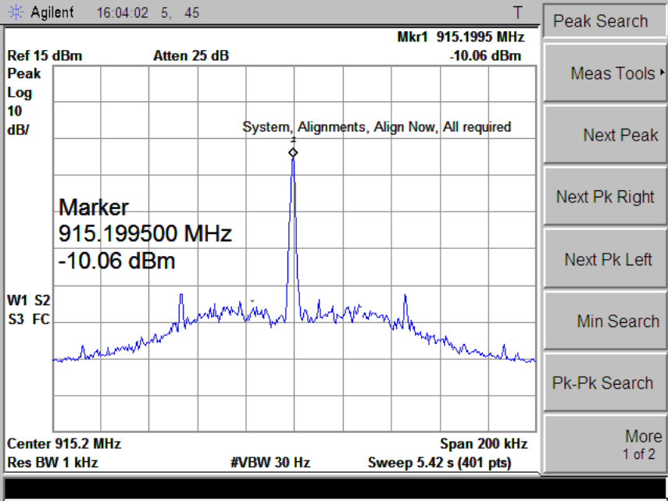

Pwr Amp=0dB attenuation:

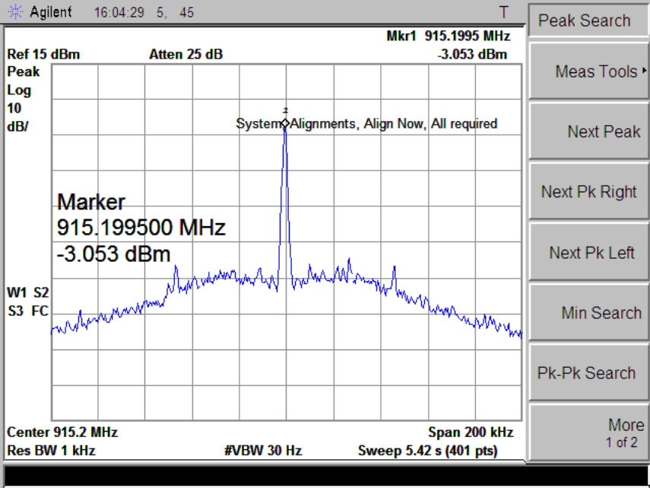

|  |  |  |
| --- | --- | --- |
| **Pwr Amp setting** | **Measured power** | **Calculated real attenuation referenced to 0-dB attenuation** |
| Off |  |  |
| 20 dB attenuation |  |  |
| 10 dB attenuation |  |  |
| 0 dB attenuation |  | This is considered as reference so 0 dB here |

<Experience collected during the completion of the measurement>

* 1. Based on the measured spectrum estimate the closed-loop bandwidth of the PLL. Explain the estimation technique applied[6].

(Hints: check the preparing material at page 10-13: „If the frequency detuning from the carrier is less than the PLL closed-loop bandwidth then the psd of local noise is constant. [...] If the detuning exceeds the PLL closed-loop bandwidth then the psd of local noise is equal to the VCO noise that typically declines by –20 dB/D.”)



<Experience collected during the completion of the measurement>

* 1. Measure and record the spurious signals in dBc as a function of frequency[7].
* Fill up the table to record at least 3 spurious signals.
* Also put a mark with numbering to the spurious signals in the spectrum.

(Hints: periodical signals, like spurious signals have line-spectrum, that appears as „spikes” in the measurement.)



|  |  |  |
| --- | --- | --- |
| Spurious number | Measured power in dBc | Frequency distance from generated signal in kHz |
| Nr. 1 |  |  |
| Nr. 2 |  |  |
| Nr. 3 |  |  |

<Experience collected during the completion of the measurement>

1. Generation of an FSK modulated signal with the TRF6900A transmitter

By double clicking into the Help field of the TRF6900A control SW, the block diagram of the chip pops up.

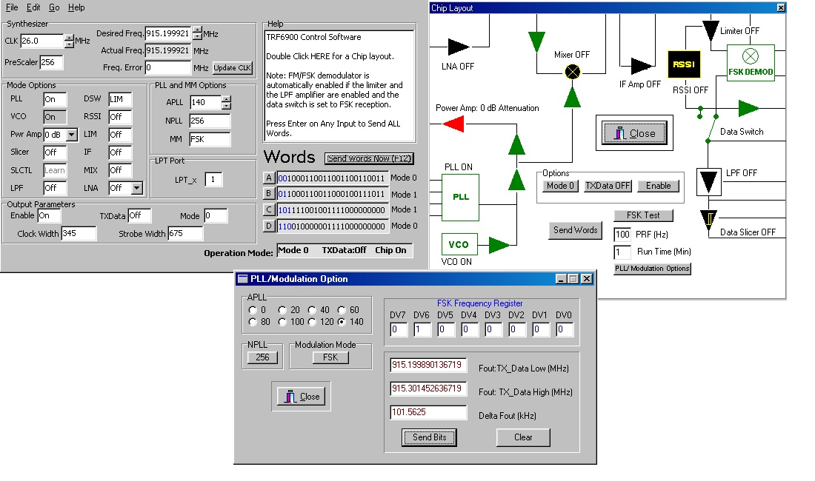

* + - Duble click into the Help field of the TRF6900A control SW makes the block diagram view of the transceiver chip pop up. Push the PLL/Modulation Options button to set the parameters of FSK modulation as follows: in the deviation register DEV, DV6=0 and all the rest bits are 0 that correponds to 50kHz deviation. Send Bits button calculates the parameters of the modulation. The frequencies corresponding to Bit ’0’ and Bit ’1’ in FSK shown in fields Tx_Data Low and Tx_Data High, respectively, while 2*deviation is given by Delta_Fout.

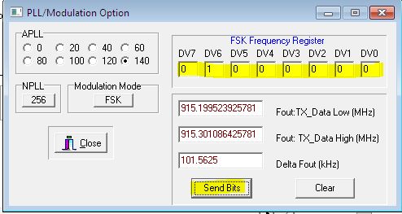

Pushing Send Words Now (F12) enters the FSK modulation paramters into the chip. By pushing the TXData button you can generate manually (in a static way) the frequencies corresponding to Bit ’1’ and Bit ’0’ in the FSK. These frequencies have to be measured using the spectrum analyser. Hint: use the Max Hold function of the spectrum analyser.

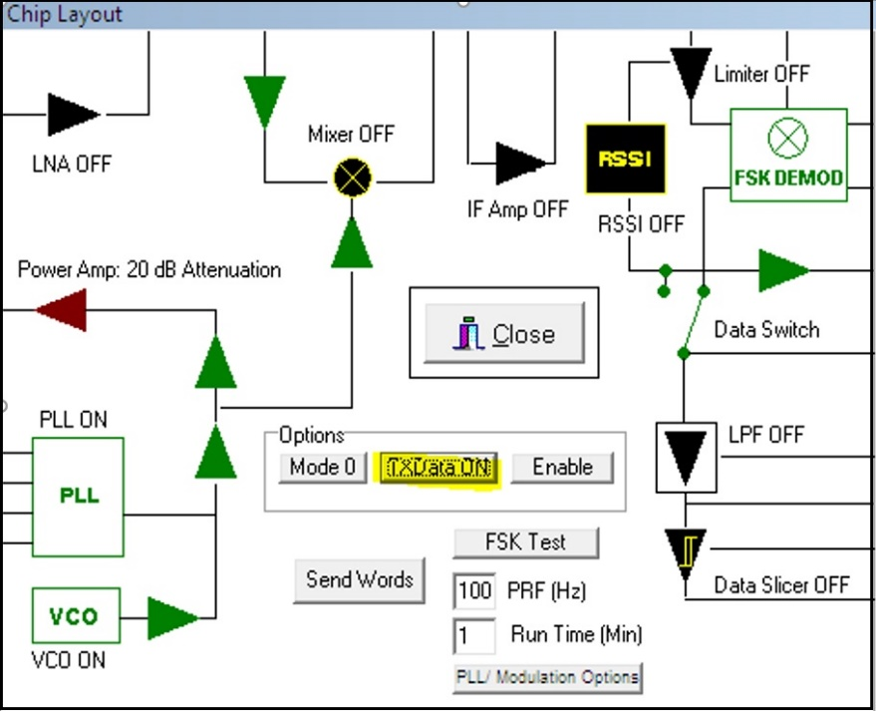

* + - Suggested settings on the spectrum analyser
    - SPAN = 1 MHz
    - RBW = 1 kHz
    - VBW = 30 Hz
  1. By completing the following “empty” spectrum and considering the setting above,

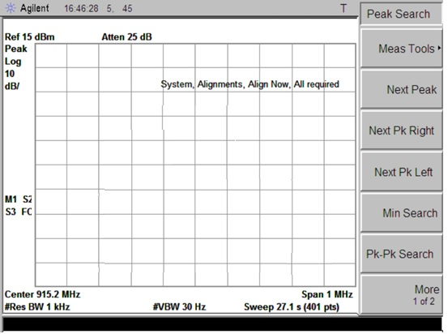

determine and record the followings:

a) sketch the spectrum (into the “empty spectrum analyzer screen”) of FSK signal that can be measured applying the above settings of the control SW,

<Experience collected during the completion of the measurement>

b) determine the two output frequencies of binary FSK carrying bit “1” and bit “0”,

<Experience collected during the completion of the measurement>

c) determine the bandwidth of FSK signal[8].

<Experience collected during the completion of the measurement>

1. Reception of an FSK signal with TRF6900A receiver

* In the block diagram window of the control software turn off the transmitter (the PA block has to be blacked out) and turn on the blocks of the receiver (turn into green the black boxes). Switch the LNA into high gain mode (vivid red).

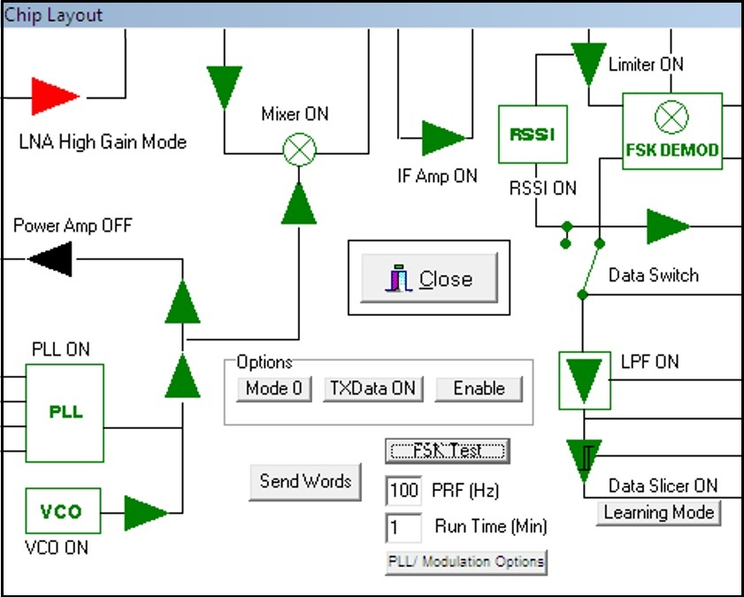

* 1. A binary FSK signal is generated by the RF signal generator[9] that is connected from the output of the RF signal generator to the RF input of the TRF6900A evaluation board!
* Draw the block diagram of the measurement configuration!
* A Suggested settings of RF signal generator
  + carrier frequency = 915.200 MHz
  + output power = -50 dBm
  + internal FSK modulation (internal analog FM modulation with square wave modulation)
  + source signaling speed = 20 kbit/s (therefore set the modulating frequency = 10 kHz)
  + deviation = 50 kHz.
  1. Calculate and record the required local frequency[10] via the control software.
* Calculate and record the input level of the TRF6900A receiver at the receiver input (do not forget to take into consideration the effect of the attenuator placed between the physical connector and the receiver input).

(Hint: check the preparing material on page 10-25: “TRF6900 Evaluation Module is embedded into test set shown in Fig. 10-11. To avoid overloading, 30-dB and 20-dB attenuators have been attached to the RX_IN input and to the TX_OUT output of the transceiver. Note, in the description of laboratory experiment the power levels measured at the inputs/outputs of the TRF6900 evaluation board are given. When setting and calculating the power levels the effect of the 30-dB and 20-dB attenuators has to be considered.”)

<Experience collected during the completion of the measurement>

* 1. Draw the block diagram of the measurement configuration that can be used to measure the signal at the input (Amp_Out terminal on the evaluation board) and output (Rx_Data_Out terminal on the evaluation board) of the Decision block (called Data slice in the control SW) of the receiver part of TRF6900A chip.

The result of the time-domain measurement:

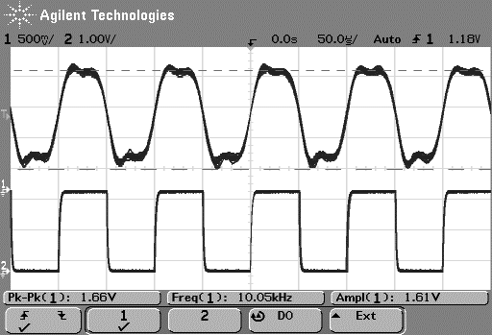

* Which signal appears at the input and at the output of the Decision circuit (Data slicer)?
* What is the role of the Decision circuit?

<Experience collected during the completion of the measurement>

* 1. Turn off the FSK modulation and measure the RSSI characteristic by setting the signal level at the TRF6900A receiver input to -70 dBm and then to -40 dBm. Calculate the sensitivity (steepness) of the RSSI circuit.
* Draw the block diagram of the measurement configuration!
* What is the role of the RSSI circuit?
* Give the steepness of the RSSI plot if the measurement results are the followings?

|  |  |
| --- | --- |
| **P_in [dBm]** | **V_RSSI [VDC]** |
| -40 | 1.265 |
| -50 | 1.083 |
| -60 | 0.908 |
| -70 | 0.780 |

<Experience collected during the completion of the measurement>

* 1. Record an eye-diagram-like waveform (can be generated using both input channels of the oscilloscope applying signal inversion on either channel). The signal to be connected to both oscilloscope channels is that of the Amp_out output. Reduce the level of the incoming RF signal until the ’eye diagram’ starts closing (tends to be noisy).

The measurement results are the followings when the eye is open:

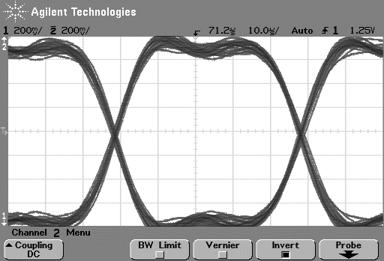

The measurement results are the followings when the eye is closing:

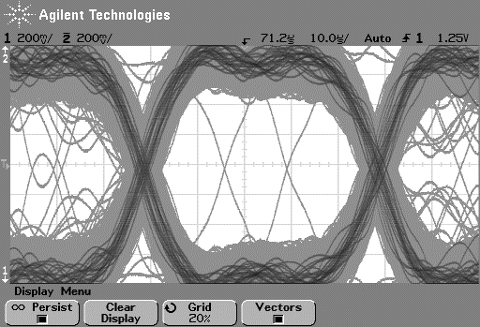

* Explain what are the consequences on the operation of the receiver when the eye-diagram is (i) closed or (ii) open?

<Experience collected during the completion of the measurement>

* 1. Determine the transfer function of the frequency discriminator based on the measurement results below. An unmodulated RF signal of power level -35 dBm to the receiver input has to be connected and the frequency discriminator output has to be measured while you keep changing the frequency of the incoming RF signal in 20kHz steps around its nominal value +/- 100kHz .
* Calculate the sensitivity (steepness) of the frequency discriminator.

|  |  |
| --- | --- |
| **Frequency[MHz]** | **DC voltage[V]** |
| 915.10 | 0.063 |
| 915.12 | 0.153 |
| 915.14 | 0.385 |
| 915.16 | 0.664 |
| 915.18 | 0.968 |
| 915.20 | 1.265 |
| 915.22 | 1.564 |
| 915.24 | 1.870 |
| 915.26 | 2.162 |
| 915.28 | 2.431 |
| 915.30 | 2.672 |

<Experience collected during the completion of the measurement>

**Photos of measuring instruments:**

1. **Oscilloscope**

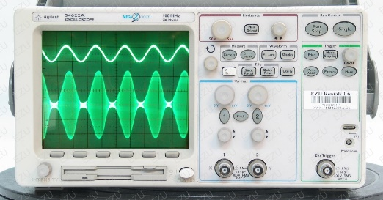

1. **Spectrum analyser**

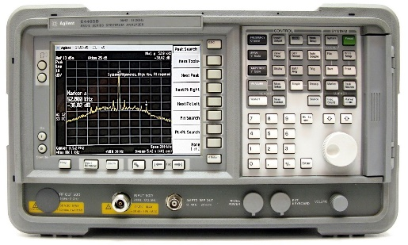

1. **RF signal geenrator**

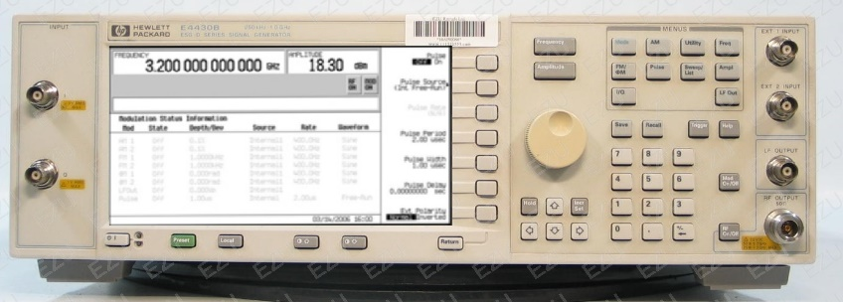

1. **Power supply**

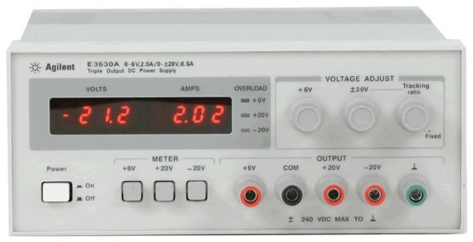

1. **Digital multimeter (DMM)**

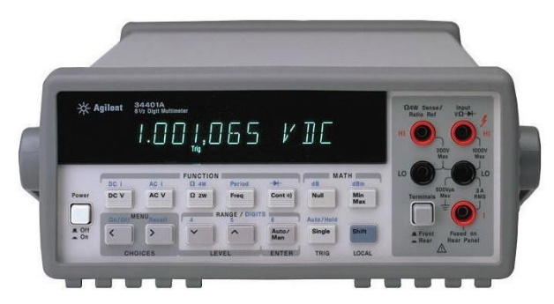

1. **Evaluation board**

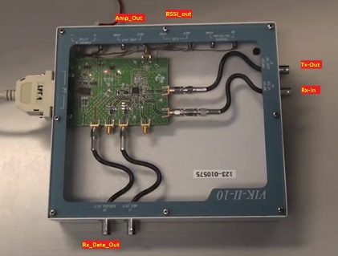

1. **Evaluation board – PC-SW**

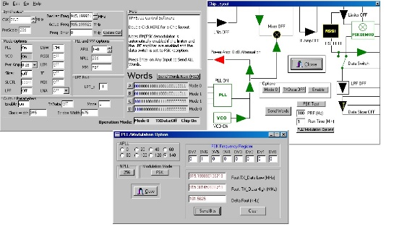

**Source of photos:**

**1. Signal Generator**

**http://www.ezurentals.com/modelimage/Agilent/E4430B/E4430BFW.jpg**

**https://www.keysight.com/en/pdx-x201773-pn-E8663D/psg-rf-analog-signal-generator-100-khz-to-9-ghz?cc=IN&lc=eng**

**2. Oscilloscope**

**www.ezurentals.com/modelimage/Agilent/54622A/54622AFW.jpg**

**https://www.interestingelectronics.com/old/henrys_interesting_electronics/small_amtx/small_amtx.html**

**3. Spectrum Analyser**

**https://www.sglabs.it/public/SgLabs_m_Agilent_E4405B_1.JPG**

**4. TRF6900A EVM**

**Labor2 preparing material**

**5. TRF6900A SW**

**Labor2 preparing material**

**6. Power Supply**

**https://www.used-line.com/power-supplies/agilent-hp/agilent-hp-e3630a/item-12618448**

1. RBW: Resolution BandWidth – the bandwidth of the band-pass filter that ’sweeps the frequency range of the spectrum analyser display’ measuring the power of the signal that falls into its bandwith; spectrum is visualized by drawing this power level measured continuously – the narrower the filter bandwidth the better the „resolution” of the spectrum displayed
2. VBW: Video BandWidth - reduces the variance of the spectrum displayed when the VBW value is decreased
3. SPAN: the width of the frequency range analysed – the frequency range around the center frequency (CENTER), i.e., [CENTER+/-SPAN/2]
4. VDC=8.5V use the power supply
5. Practical usage of Pwr Amp: the receiver chip acknowledges the reception of too high level of incoming signal forcing the transmitter to reduce the radiated power level. Here, controlled attenuators are used to change signal levels.
6. Identification of a band-pass-like spectrum.
7. Relative to the carrier (see letter ’c’ in dBc for carrier): P_dBc_spur=P_dBm_spur-P_dBm_carrier
8. Hint: refer to the Carson rule!
9. The signal generator offers only FM modulation however FM modulation applying square-wave as modulating waveform can be considered as FSK.
10. The TRF6900A implements a superheterodyne receiver, i.e., an intermediate frequency (IF) stage is applied, here at 10.7MHz. Operation principle: the mixer (analog multiplier) multiplies the incoming RF signal with the signal of the local oscillator, i.e., the well-known trigonometrical identity 2*cos(x)*cos(y)=cos(x+y)+cos(x-y) can be exploited. After low-pass filtering the high frequency component only the substraction remains, i.e., (x-y)=10.7MHz.