Exercise Report
(Lab2-M9)
Subject of this exercise: | Study of Analog Phase-Locked Loop (APLL)
Students – Student code: | <me>-student code  <myself> -student code  <I> -student code
Course/code: | <course>, <group>
Date & time: | 20<YY>. <MM>. <DD>.
Lecturer today:
Equipment in use, device under test
Oszcilloscope | Agilent 54622A
Power supply | Agilent E3630
Synchronizable function generators | Agilent 33220A-Option 001
Digital multimeter (6½ digit) | Agilent 33401A
Digital multimeter (3½ digit) | Metex ME-22T
Exercises
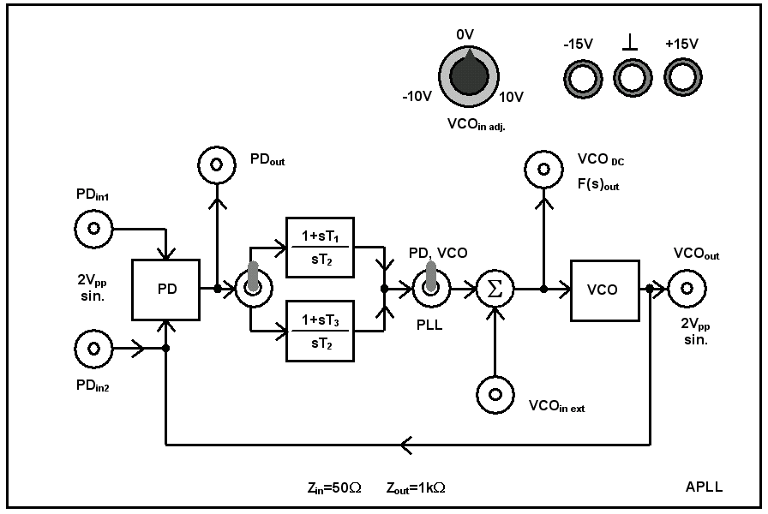
Test panel Fig.9-1.
- Measuring of the loop elements of the APLL
  - Obtaining the PD curve

θ₂ [º] | u_{d} [V] | θ_{e} [º] |  | θ₂ [º] | u_{d} [V] | θ_{e} [º]
180 | -0.03022 | -180 |  | 0 | 0.0491 | 0
170 | -0.17829 | -170 |  | -10 | 0.1974 | 10
160 | -0.3209 | -160 |  | -20 | 0.3403 | 20
150 | -0.4535 | -150 |  | -30 | 0.4726 | 30
140 | -0.5722 | -140 |  | -40 | 0.5915 | 40
130 | -0.673 | -130 |  | -50 | 0.6922 | 50
120 | -0.7533 | -120 |  | -60 | 0.7724 | 60
110 | -0.8103 | -110 |  | -70 | 0.8293 | 70
100 | -0.8422 | -100 |  | -80 | 0.8614 | 80
90 | -0.8484 | -90 |  | -90 | 0.8674 | 90
80 | -0.8286 | -80 |  | -100 | 0.8476 | 100
70 | -0.7834 | -70 |  | -110 | 0.8022 | 110
60 | -0.7137 | -60 |  | -120 | 0.7327 | 120
50 | -0.6227 | -50 |  | -130 | 0.641 | 130
40 | -0.5121 | -40 |  | -140 | 0.5305 | 140
30 | -0.3856 | -30 |  | -150 | 0.4039 | 150
20 | -0.2471 | -20 |  | -160 | 0.2655 | 160
10 | -0.10076 | -10 |  | -170 | 0.11925 | 170
0 | 0.0491 | 0 |  | -180 | -0.03037 | 180

When θ_{e} is small (|θ_{e}| < 45 º)
u_{d}(t) = K_{d} θ_{e}
u_{d1} = V
u_{d2} = V
θ_{e1} = º
θ_{e2} = º

Kd’= [V/º]
Kd = [V/rad]
Measurement setup
<Block diagram>

Matlab code:

<PD curve - plot>

<Experience collected during the completion of the measurement>
  - Obtaining VCO curve

u_{f} [V] | f₂ [Hz]
-10,14 | 78700
-8,00 | 81030
-6,09 | 83110
-4,09 | 85290
-2,02 | 87540
--0,04 | 89690
2,05 | 91980
4,05 | 94160
6,08 | 96370
8,00 | 98460
9,58 | 100180

Measurement setup
<Block diagram>

Matlab code:

<VCO curve - plot>

u_{f1} = V
u_{f2} = V
f₁ = kHz
f₂ = kHz
K_{v}’= [kHz/V]
K_{v}= [k rad/Vs]

<Experience collected during the completion of the measurement>

  - Calculating the free-running frequency of the VCO

Measurement setup
<Block diagram>

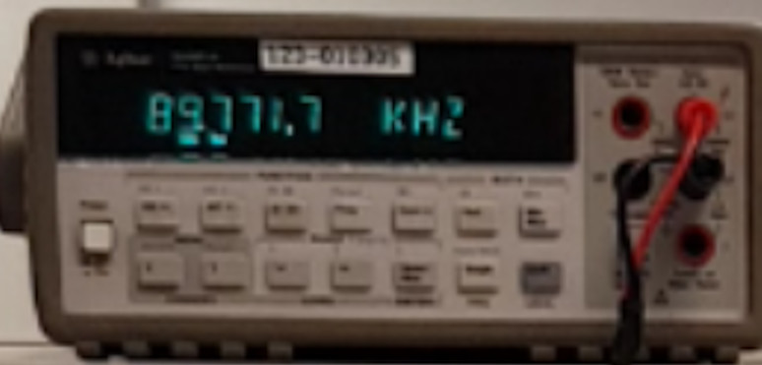
f₀ = kHz; ω₀ = k
<Experience collected during the completion of the measurement>

VCO operation formula:
ω₂ = [rad/s].
- Obtaining the locking- and tracking ranges of the APLL
  - Obtaining the locking range
Measurement setup
<Block diagram>

The following videos are available for the accomplishment of the tasks:
https://web.microsoftstream.com/video/cb984119-5a22-4c83-afd5-43def4a42845

https://web.microsoftstream.com/video/1b8a757d-773c-4c8a-8a6e-c7406a53918f

https://web.microsoftstream.com/video/30e9bcfe-35b3-4e28-be50-16e61a79b948

1. method
f₁ = kHz
f₂ = kHz
2Δf_{P}= kHz

< ábra>

2. Lissajous’s method (Lissajou curve)
<Plot>

<Experience collected during the completion of the measurement>

  - Obtaining tracking range
f₁ = kHz
f₂ = kHz
2Δf_{H}= kHz

<Experience collected during the completion of the measurement>
- Implementation of analog FM demodulator and obtaining its curve
Obtain the curve of FM demodulator
ζ=1 Reference signal: 100 Hz → 0 dB
f [Hz] | u_{f} [dB]
100 | -0.00064303
300 | 0.18337
500 | 0.4616
700 | 0.74474
900 | 0.97374
1100 | 1.13322
1300 | 1.22228
1500 | 1.2507
1700 | 1.22736
1900 | 1.16161
2100 | 1.0613
2300 | 0.93234
2500 | 0.78107
2700 | 0.60701
2900 | 0.41751
3100 | 0.21505
3300 | -0.0010619
3500 | -0.2267
3700 | -0.46052
3900 | -0.70269
4100 | -0.95055
4300 | -1.20346
4500 | -1.47079
4700 | -1.72217
4900 | -1.9869
5100 | -2.2545
5300 | -2.5228
5500 | -2.794
5700 | -3.0672
5900 | -3.3391
6100 | -3.6124

Measurement setup
<Block diagram>

Matlab code:

<FM demodulator curve - plot>

<Experience collected during the completion of the measurement>

- Determination of APLL closed-loop transfer function
  - Determination of closed-loop transfer function, [H(s)]:
Matlab code:

<Closed-loop transfer function - plot>

Closed-loop transfer function when ζ=1:
Parameters:
Kv= [rad/Vs]; Kd= [V/rad]; τ1= [s/rad];
τ2= [s/rad].
ζ= ; ω_{n}= [rad/s]; ω_{b}= [rad/s];

<Experience collected during the completion of the measurement>

  - Determination of the error function, [1-H(s)]:
Matlab code:

<Error-function - plot>

Error function, when ζ=1:
Parameters:
Kv= [rad/Vs]; Kd= [V/rad]; τ1= [s/rad];
τ2= [s/rad].
ζ= ; ω_{n}= [rad/s].

<Experience collected during the completion of the measurement>
- Implementation and measurement of digital FSK demodulator
Measurement in case of FSK with small deviation
Settings:
Frequency: 90 kHz
Frequency hopping: 92 kHz
Modulation frequency: 200 Hz
ζ=1

Measurement setup
<Block diagram>

The following videos are available for the accomplishment of the tasks:
https://web.microsoftstream.com/video/1e1fb90a-ce0a-4ba2-be8e-5974a635beea

https://web.microsoftstream.com/video/87eff464-c512-476a-9d55-044da88f56bb

<plot>

<Experience collected during the completion of the measurement>

Measurement of FSK with big deviation (collapsing the locked state, generating locking transient)
Settings:
Frequency: 90 kHz
Frequency hopping: 97 kHz
Modulation frequency: 200 Hz
ζ=1

< plot>

<Experience collected during the completion of the measurement>

- Measurement of APLL dynamics characterized by two different damping factors (ζ= 1 and 0,25)
  - Hop in the frequency of the reference signal
Settings:
Frequency: 90 kHz
Frequency hopping: 92 kHz
Modulation frequency: 200 Hz
ζ=1

< plot>

Settings:
Frequency: 90 kHz
Frequency hopping: 92 kHz
Modulation frequency: 200 Hz
ζ=0,25

< plot>

<Experience collected during the completion of the measurement>

  - Perturbation applied on VCO input

Measurement setup
<Block diagram>
The following videos are available for the accomplishment of the tasks:
https://web.microsoftstream.com/video/6ef41c5d-bbff-4cfa-a476-507c1014f3cf

https://web.microsoftstream.com/video/94dc64aa-720c-4833-a11f-bdd07e14adaf

https://web.microsoftstream.com/video/a79b713d-a8fe-4b53-9e5b-ce1a2146859d

https://web.microsoftstream.com/video/aac09335-b401-4196-be3d-c83e7318c702

Parameters of perturbation signal:
Frequency:100Hz
Amplitude: 1Vpp
Waveform: square
Duty cycle: 50%

ζ=1

<plot>

Parameters of perturbation signal:
Frequency:100Hz
Amplitude: 1Vpp
Waveform: square
Duty cycle: 50%

ζ=0.25

< plot>

<Experience collected during the completion of the measurement>

Complementary measurement tasks
- Double-frequency component measured at the output of the phase detector
The following video is available for the accomplishment of the tasks
(where ch1: PD_{in1} and ch2: F(s)_{out} ):

https://web.microsoftstream.com/video/b01f626a-a16b-40f3-bdc7-75c1f3cbe671

Measurement setup
<Block diagram>
<plot>

<Experience collected during the completion of the measurement>

