Exercise Report
(Lab2-M9)
Subject of this exercise: | Study of Analog Phase-Locked Loop (APLL)
Students – Student code: | <me>-student code  <myself> -student code  <I> -student code
Course/code: | <course>, <group>
Date & time: | 20<YY>. <MM>. <DD>.
Lecturer today:
Equipment in use, device under test
Oszcilloscope | Agilent 54622A
Power supply | Agilent E3630
Synchronizable function generators | Agilent 33220A-Option 001
Digital multimeter (6½ digit) | Agilent 33401A
Digital multimeter (3½ digit) | Metex ME-22T
Exercises
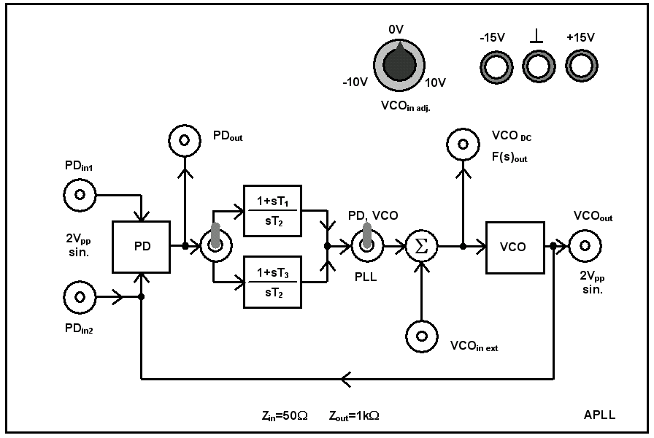
Test panel Fig.9-1.
- Measuring of the loop elements of the APLL
Obtaining the PD curve

θ₂ [º] | u_{d} [V] | θ_{e} [º] |  | θ₂ [º] | u_{d} [V] | θ_{e} [º]
180 |  | -180 |  | 0 |  | 0
170 |  | -170 |  | -10 |  | 10
160 |  | -160 |  | -20 |  | 20
150 |  | -150 |  | -30 |  | 30
140 |  | -140 |  | -40 |  | 40
130 |  | -130 |  | -50 |  | 50
120 |  | -120 |  | -60 |  | 60
110 |  | -110 |  | -70 |  | 70
100 |  | -100 |  | -80 |  | 80
90 |  | -90 |  | -90 |  | 90
80 |  | -80 |  | -100 |  | 100
70 |  | -70 |  | -110 |  | 110
60 |  | -60 |  | -120 |  | 120
50 |  | -50 |  | -130 |  | 130
40 |  | -40 |  | -140 |  | 140
30 |  | -30 |  | -150 |  | 150
20 |  | -20 |  | -160 |  | 160
10 |  | -10 |  | -170 |  | 170
0 |  | 0 |  | -180 |  | 180

When θ_{e} is small (|θ_{e}| < 45 º)
u_{d}(t) = K_{d} θ_{e}
u_{d1} = V
u_{d2} = V
θ_{e1} = º
θ_{e2} = º

Kd’= [V/º]
Kd = [V/rad]
Matlab code:

<PD curve - plot>

<Experience collected during the completion of the measurement>
Obtaining VCO curve

u_{f} [V] | f₂ [kHz]
Matlab code:

<VCO curve - plot>

u_{f1} = V
u_{f2} = V
f₁ = kHz
f₂ = kHz
K_{v}’= [kHz/V]
K_{v}= [k rad/Vs]

<Experience collected during the completion of the measurement>

Calculating the free-running frequency of the VCO
f₀ = kHz; ω₀ = k
<Experience collected during the completion of the measurement>

VCO operation formula:
ω₂ = [rad/s].
Obtaining the locking- and tracking ranges of the APLL
Obtaining the locking range
1. method
f₁ = kHz
f₂ = kHz
2Δf_{P}= kHz

< ábra>

2. Lissajous’s method (Lissajou curve)
<Plot>

<Experience collected during the completion of the measurement>

Obtaining tracking range
f₁ = kHz
f₂ = kHz
2Δf_{H}= kHz

<Experience collected during the completion of the measurement>
Implementation of analog FM demodulator and obtaining its curve
Obtain the curve of FM demodulator
ζ=1 Reference signal: 100 Hz → 0 dB
f [Hz] | u_{f} [dB]
100
300
500
700
900
1100
1300
1500
1700
1900
2100
2300
2500
2700
2900
3100
3300
3500
3700
3900
4100
4300
4500
4700
4900
5100
5300
5500
5700
5900
6100

Matlab code:

<FM demodulator curve - plot>

<Experience collected during the completion of the measurement>
Implementation and measurement of digital FSK demodulator
Measurement in case of FSK with small deviation
Settings:
Frequency: 90 kHz
Frequency hopping: 92 kHz
Modulation frequency: 200 Hz
ζ=1

<plot>

<Experience collected during the completion of the measurement>

Measurement of FSK with big deviation (collapsing the locked state, generating locking transient)
Settings:
Frequency: 90 kHz
Frequency hopping: 97 kHz
Modulation frequency: 200 Hz
ζ=1

< plot>

<Experience collected during the completion of the measurement>

