**Measurement results for the „M7. A/D and D/A converters” lab**

Select the measurement for each task according to your Neptun code. Include the processed measurement data for every exercise in your lab report.

# Integral nonlinearity

If your neptun code begins with:: '0', '5', 'A', 'F', 'K', 'P', 'U', 'Z'

**INL1:**

dacin =

0 400 800 1200 1600 2000 2400 2800 3200 3600 4000

dacout =

0.0089 0.2428 0.4857 0.7285 0.9710 1.2143 1.4584 1.7030 1.9471 2.1914 2.4347

If your neptun code begins with:: '1', '6', 'B', 'G', 'L', 'Q', 'V'

**INL2:**

dacin =

0 350 700 1050 1400 1750 2100 2450 2800 3150 3500 3850

dacout =

0.0089 0.2124 0.4253 0.6372 0.8496 1.0619 1.2753 1.4886 1.7029 1.9169 2.1301 2.3434

If your neptun code begins with:: '2', '7', 'C', 'H', 'M', 'R', 'W'

**INL3:**

dacin =

200 600 1000 1400 1800 2200 2600 3000 3400 3800

dacout =

0.1216 0.3648 0.6069 0.8496 1.0924 1.3361 1.5801 1.8256 2.0692 2.3129

If your neptun code begins with:: '3', '8', 'D', 'I', 'N', 'S', 'X'

**INL4:**

dacin =

200 550 900 1250 1600 1950 2300 2650 3000 3350 3700 4050

dacout =

0.1216 0.3344 0.5460 0.7589 0.9708 1.1837 1.3969 1.6108 1.8255 2.0387 2.2520 2.4647

If your neptun code begins with:: '4', '9', 'E', 'J', 'O', 'T', 'Y'

**INL5:**

dacin =

400 800 1200 1600 2000 2400 2800 3200 3600 4000

dacout =

0.2428 0.4857 0.7285 0.9708 1.2142 1.4583 1.7030 1.9471 2.1914 2.4346

# Differential nonlinearity

**If the second character of your neptun code is: '0', '5', 'A', 'F', 'K', 'P', 'U', 'Z'**

**DNL1:**

dacin =

2040 2041 2042 2043 2044 2045 2046 2047 2048 2049 2050

dacout =

1.2389 1.2395 1.2402 1.2407 1.2414 1.2420 1.2426 1.2432 1.2436 1.2442 1.2448

If the second character of your neptun code is: '1', '6', 'B', 'G', 'L', 'Q', 'V'

**DNL2:**

dacin =

2045 2046 2047 2048 2049 2050 2051 2052 2053 2054 2055

dacout =

1.2420 1.2426 1.2433 1.2436 1.2443 1.2449 1.2455 1.2460 1.2467 1.2473 1.2479

If the second character of your neptun code is: '2', '7', 'C', 'H', 'M', 'R', 'W'

**DNL3:**

dacin =

1020 1021 1022 1023 1024 1025 1026 1027 1028 1029 1030

dacout =

0.6191 0.6197 0.6204 0.6210 0.6213 0.6219 0.6226 0.6232 0.6238 0.6244 0.6250

If the second character of your neptun code is: '3', '8', 'D', 'I', 'N', 'S', 'X'

**DNL4**:

dacin =

3065 3066 3067 3068 3069 3070 3071 3072 3073 3074

dacout =

1.8655 1.8661 1.8667 1.8674 1.8680 1.8685 1.8692 1.8696 1.8702 1.8708

If the second character of your neptun code is: '4', '9', 'E', 'J', 'O', 'T', 'Y'

**DNL5**:

dacin =

505 506 507 508 509 510 511 512 513 514 515

dacout =

0.3067 0.3073 0.3080 0.3086 0.3092 0.3098 0.3105 0.3109 0.3115 0.3121 0.3127

# Glitch energy

If the third character of your neptun code is: '0', '5', 'A', 'F', 'K', 'P', 'U', 'Z'

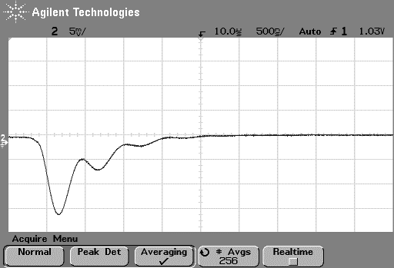

If the third character of your neptun code is: '1', '6', 'B', 'G', 'L', 'Q', 'V'

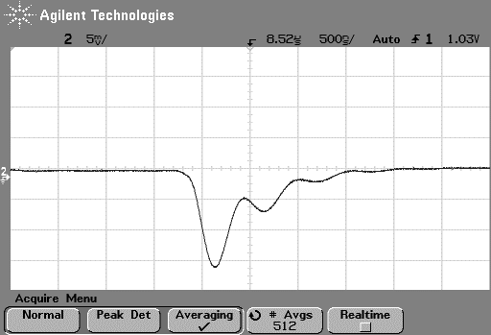

If the third character of your neptun code is: '2', '7', 'C', 'H', 'M', 'R', 'W'

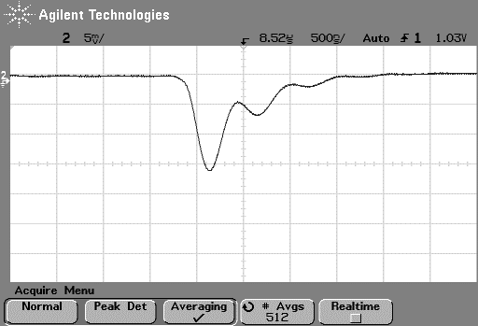

If the third character of your neptun code is: '3', '8', 'D', 'I', 'N', 'S', 'X'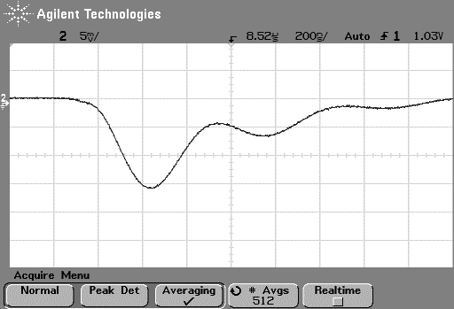

If the third character of your neptun code is: '4', '9', 'E', 'J', 'O', 'T', 'Y'

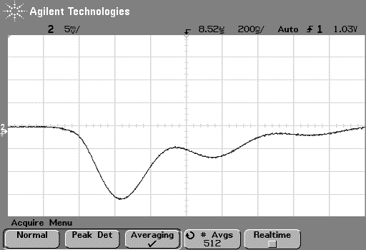

# Quantization error

If the fourth character of your neptun code is: '0', '5', 'A', 'F', 'K', 'P', 'U', 'Z'

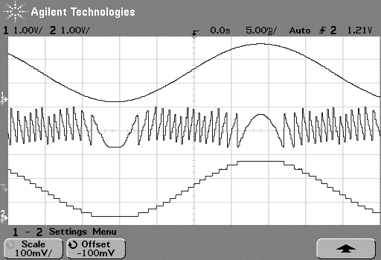

If the fourth character of your neptun code is: '1', '6', 'B', 'G', 'L', 'Q', 'V'

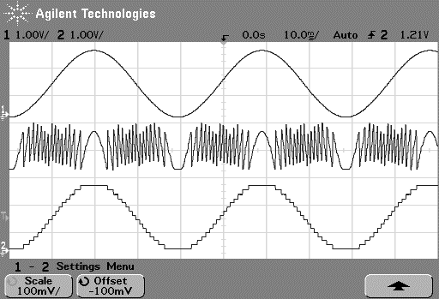

If the fourth character of your neptun code is: '2', '7', 'C', 'H', 'M', 'R', 'W'

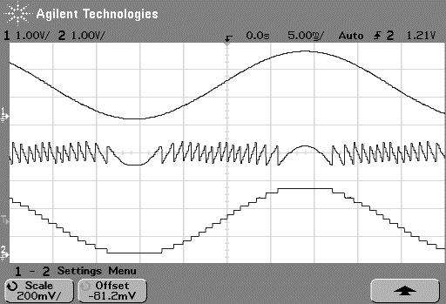

If the fourth character of your neptun code is: '3', '8', 'D', 'I', 'N', 'S', 'X'

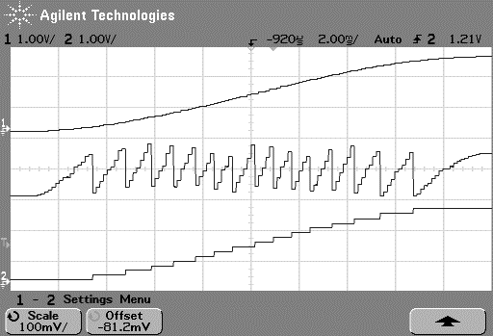

If the fourth character of your neptun code is: '4', '9', 'E', 'J', 'O', 'T', 'Y'

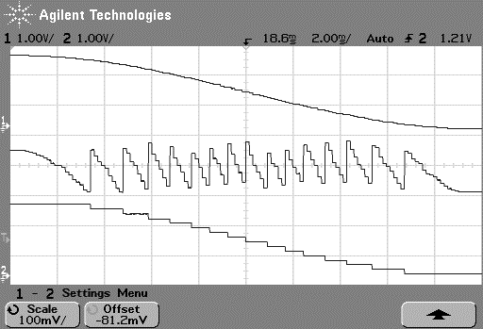

# Coherent sampling

If the fifth character of your neptun code is: '0', 'A', 'K', 'U'



If the fifth character of your neptun code is: '1', 'B', 'L', 'V'



If the fifth character of your neptun code is: '2', 'C', 'M', 'W'



If the fifth character of your neptun code is: '3', 'D', 'N', 'X'



If the fifth character of your neptun code is: '4', 'E', 'O', 'Y'



If the fifth character of your neptun code is: '5', 'F', 'P', 'Z'



If the fifth character of your neptun code is: '6', 'G', 'Q'



If the fifth character of your neptun code is: '7', 'H', 'R'



If the fifth character of your neptun code is: '8', 'I', 'S'



If the fifth character of your neptun code is: '9', 'J', 'T'

