Scope of the measurement: | Testing basic transistor circuits  (Measurement no 5)
Measurement done by: | <student’s name>  < student’s name >
Measuring group: | <course>, <group number>
Date: | <day>, <month>, <year>
Course leader: | <teachers’ name>
Board number:
Applied instruments
Digital oscilloscope | AGILENT 54622A
Function generator | AGILENT 33220A
Digital multimeter (6½ digit)  Power Supply | AGILENT 33401A  AGILENT E3630
Test panel
Measurement tasks
- Common emitter circuit (without feedback)
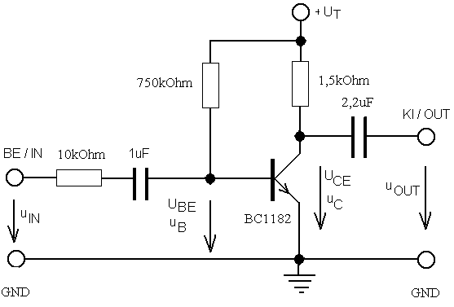
Using appropriate jumpers, set up the circuit corresponding to the above figure. Connect the power supply and adjust the supply voltage accordingly to the value given direction of the homework, so that on the cathode of the diode D (protection against reverse polarity) one can measure voltage +U_{T} .
1.1 Measure the voltages of the operating point and calculate the values of I_{C}, I_{B}, and B.
U_{T} =
U_{CE} =
U_{BE} =
I_{C} =
I_{B} =
B =

1.2 Connect a 1 kHz sine-wave signal to the amplifier input. Verify the operation of the amplifier by measuring the input and output signal with oscilloscope. Set the amplitude and frequency of the input signal so that the signal at the output be undistorted and without phase shift ( CH1=OUT, CH2= IN ).
On the basis of the equivalent circuit (see Fig.5-3. of the instruction file), measure with oscilloscope and calculate the values of the following parameters:
h_{11e} = , (how can the condition be provided?)
h₂₁ = ß :
Voltage gain:
Output resistance, when an external load is connected by jumper JP15:
Compare the results with those calculated in the homework.
1.3 Analysis of the output voltage swing of the unloaded amplifier.
Observe the distortion of the output voltage under voltage-driven (JP1 ON) and under current-driven (JP1 OFF) condition. Explain the observed behavior.
For both cases, determine the maximum allowable value of the input and output voltage.

2. Common emitter circuit with feedback resistor in emitter.
Set up the circuit shown on the figure below. In the following measurements make sure that the input jumper J1 is in ON position (i.e. short circuit of the 10 kohm serial resistor).
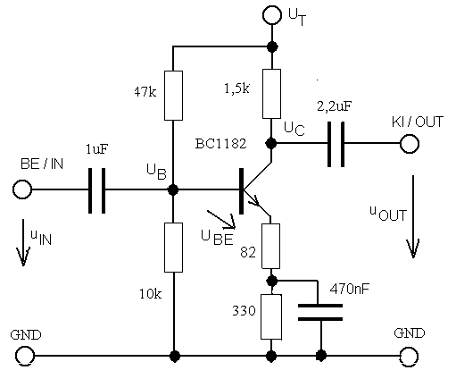
2.1 Measure the operating point voltages of points B, E and C and compare them with the values calculated in the homework! Calculate the actual value of currents I_{E} and I_{C}.
2.2 Using 1 kHz sine-wave input signal, measure the output voltage swing and the gain of the unloaded amplifier, as well as those of the amplifier being loaded by an 1 kohm resistor. Calculate the output resistance of the amplifier.
2.3 Measurement of the amplitude and phase response
For this measurement, use the OSCBODE program.
Decrease the amplitude of the signal measured in the previous point to one third of the original level. Measure the amplitude and the phase response in 3 points per decade (2; 5; 10) in the 20 Hz - 2 MHz frequency range and plot the measured and computed values as Bode-diagram.
3 curves can be plotted in the same diagram (bode.xls file). Plot the Bode diagrams under the following three conditions:
2.3.1. Unloaded amplifier (JP7, JP14 and JP15 OFF)
2.3.2. Unloaded amplifier with emitter capacitor (JP7 and JP15 OFF, JP14 ON)
2.3.3. Loaded amplifier with collector capacitor (JP14 OFF, JP7 and JP15 ON)
Evaluate the diagrams and compare the cut-off points with the values calculated in the homework.

2.4. Measurement of the square-wave response of the amplifier
Connect a 1 kHz square-wave signal to the input of the unloaded amplifier (JP7, JP14 and JP15 OFF)
2.4.1 Plot the output signal characteristic in time domain and measure the rise time and the amplitude drop. (Which time constant is related to the amplitude drop?)
2.4.2 Measure the rise time again in case of the unloaded amplifier with collector capacitor (JP7 ON).
2.4.3 Connect the emitter capacitor as well (JP14 ON) and measure the overshoot of the signal. (Take care of avoiding saturation of the circuit (cut-off of the overshoot)).
Explain the results and relate them to your frequency domain measurements.
3. Analysis of the phase splitter circuit
Set up the circuit shown on the figure below.

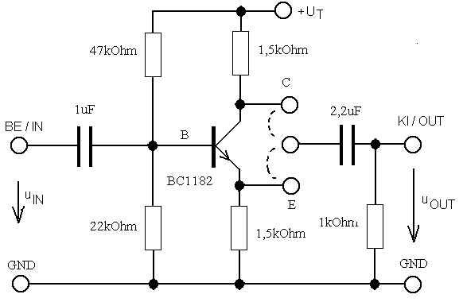

3.1. Measure the DC voltages of the B, E and C points and calculate the emitter current of the operating point.
Connect a 1 kHz, 1 V_{pp} sine-wave signal to the input. Connect the Y1 and Y2 channels of the oscilloscope to points C and E and observe the operation of the circuit (phase relations, signal levels). Using the Quick Measure Peak-Peak function of the oscilloscope, measure simultaneously the signal on the collector and the emitter at following conditions:
3.1.1 Without external load:
3.1.2 With a 1 kohm load connected to the emitter (JP13, JP15 ON):
3.1.3 With a 1 kohm load connected to the collector (JP12, JP15 ON):
4. Analysis of the common collector (emitter-follower) circuit
The previous phase splitter circuit can be converted into an emitter-follower by connecting the jumper JP8.
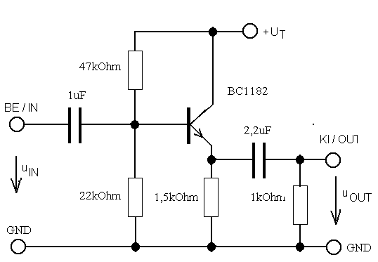

Connect one channel of the oscilloscope to the base and the other channel to the emitter of the transistor and set the gain and the horizontal axes of both channels to the same level. Connect a 1 kHz sine-wave signal to the input. Observe and explain the operation of the circuit! Increase the level of the input signal until the output (i.e. the emitter voltage) starts to be distorted.
4.1 Measure the value of the maximum undistorted output voltage.
4.2 Load the emitter follower with a 1 kohm resistor.
What did you observe? Determine the value of the maximum available output signal.
4.3 Measure the output resistance of the emitter-follower at f =10 kHz, while R_{g}=0 and R_{g}=∞.
Design the setup of your measurement. Measure the voltage proportional to the output resistance at point E with the Agilent Multimeter in AC voltage measurement mode. In both cases, check the results of the measurement by calculations.

